**Implementing a Team Communication Solution Using Mattermost and AWS.**

DESCRIPTION

You are a Cloud engineer working on a Team Communication Solution project for a big MNC. The client has compliance policies which do not allow them to use services managed by third parties.  
The client wants a team communication solution that can be managed and hosted on servers that are controlled by them.

**Steps to Perform:**

1. Implement two different subnets (one public and the other private) in a custom VPC
2. Install and configure MySQL on an Ubuntu 18.04 instance on the private subnet (Hint: Use a bastion host and a NAT instance)
3. Install and configure Mattermost on an Ubuntu 18.04 instance on the public subnet
4. Configure the security groups to allow the ports
5. Test the installation by accessing the IP of the public instance in a browser

Create VPC

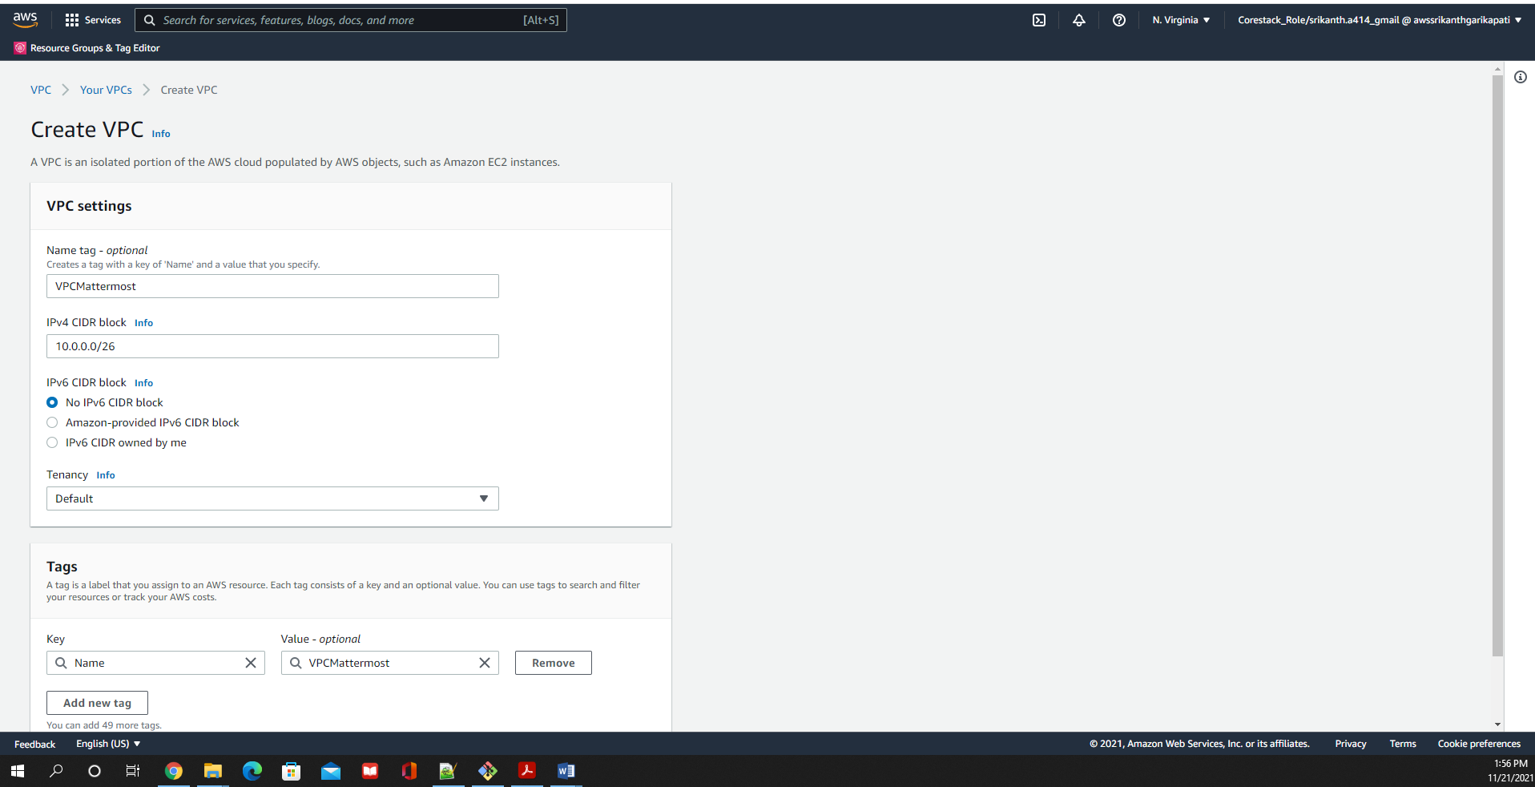

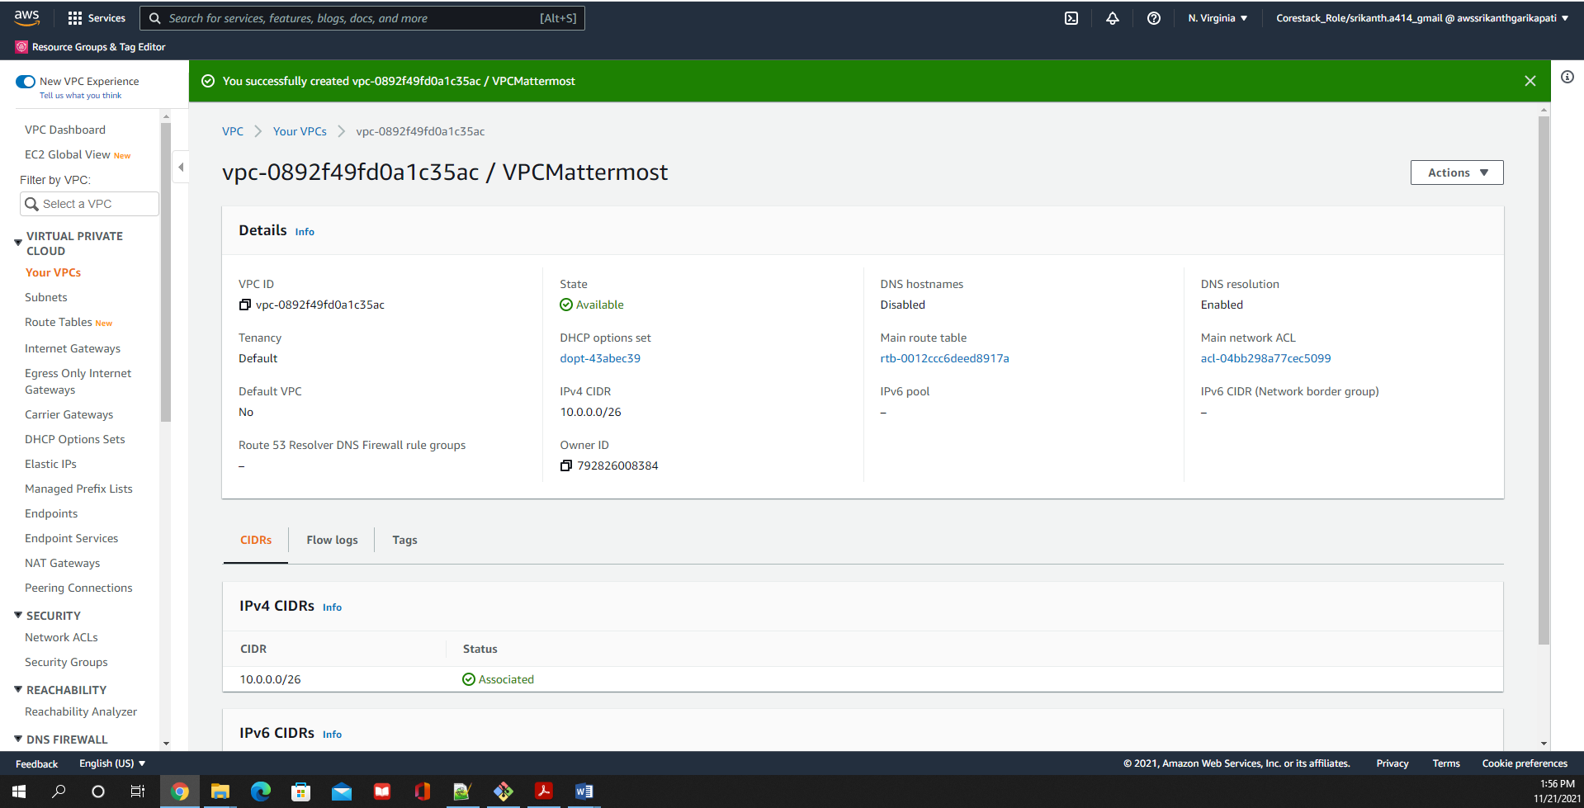

Edit DNSHostNames :

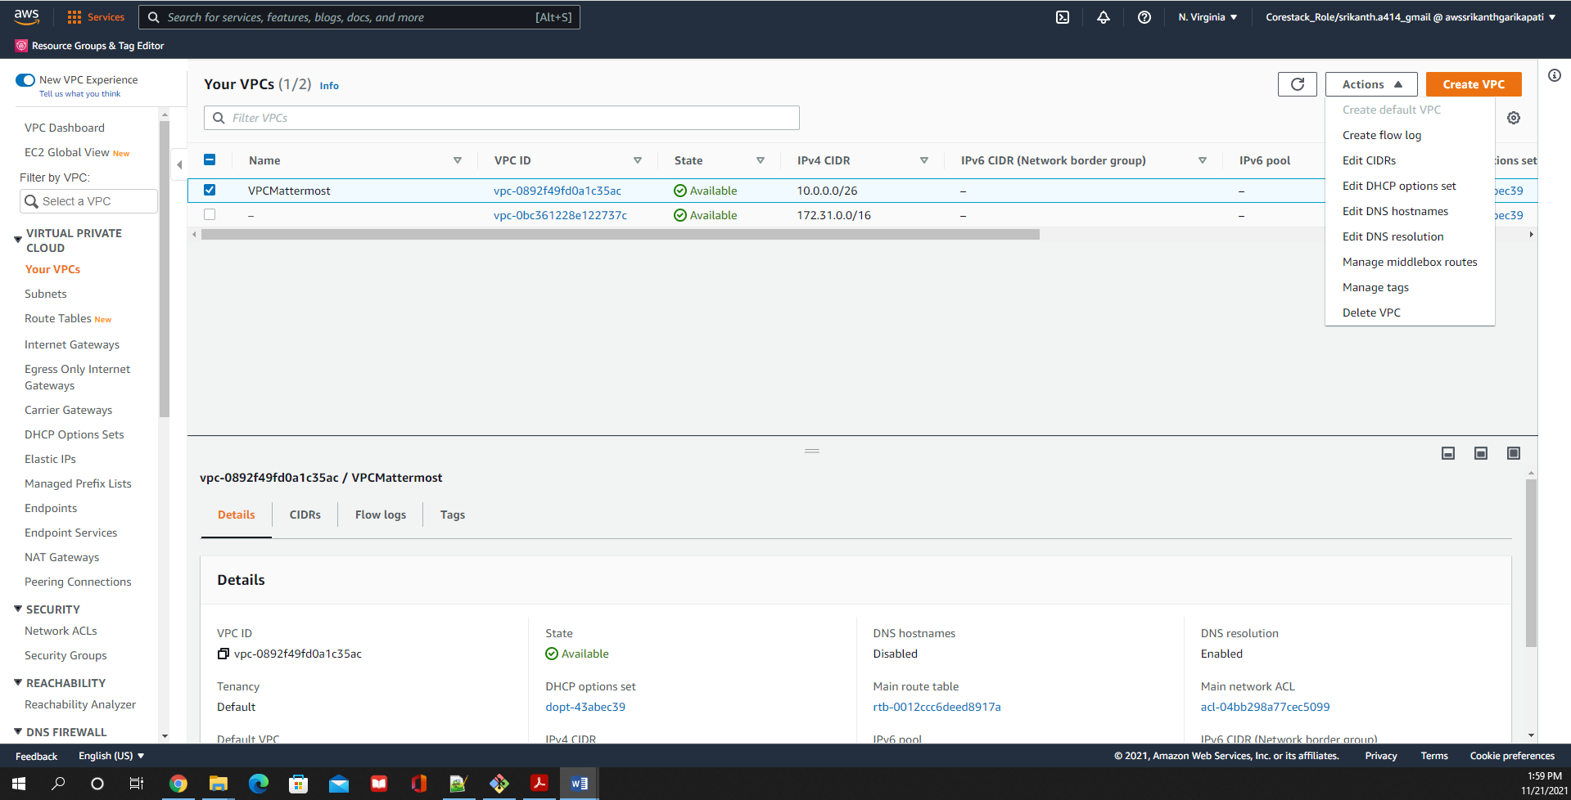

Enable DNSHostNames for the VPN

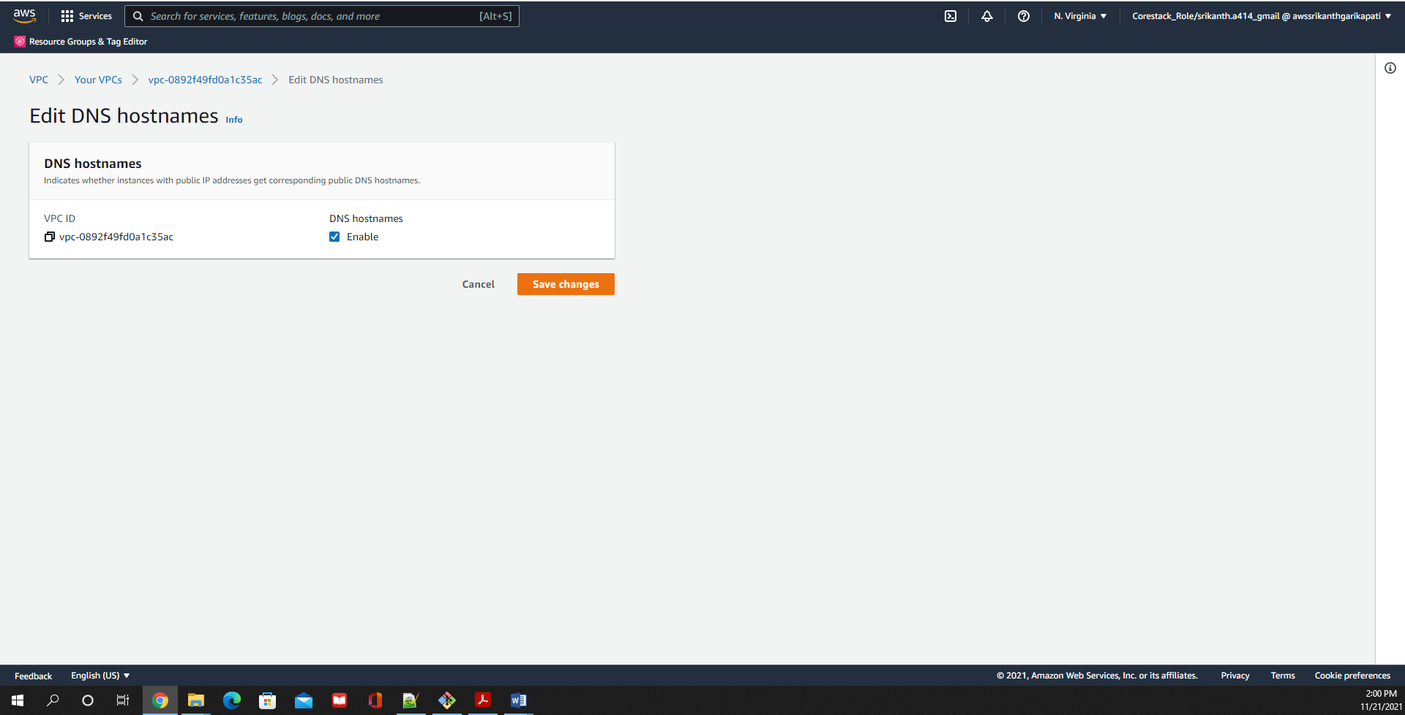

Create Internet Gateway

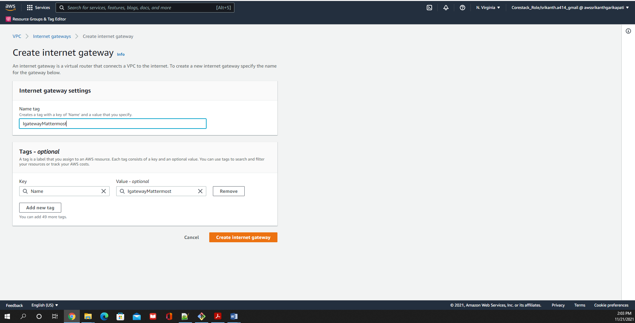

Attach Internet Gateway to VPC

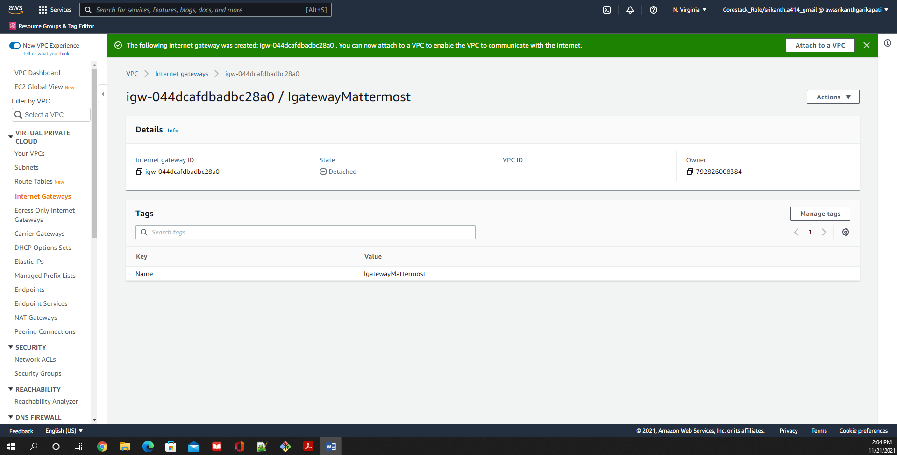

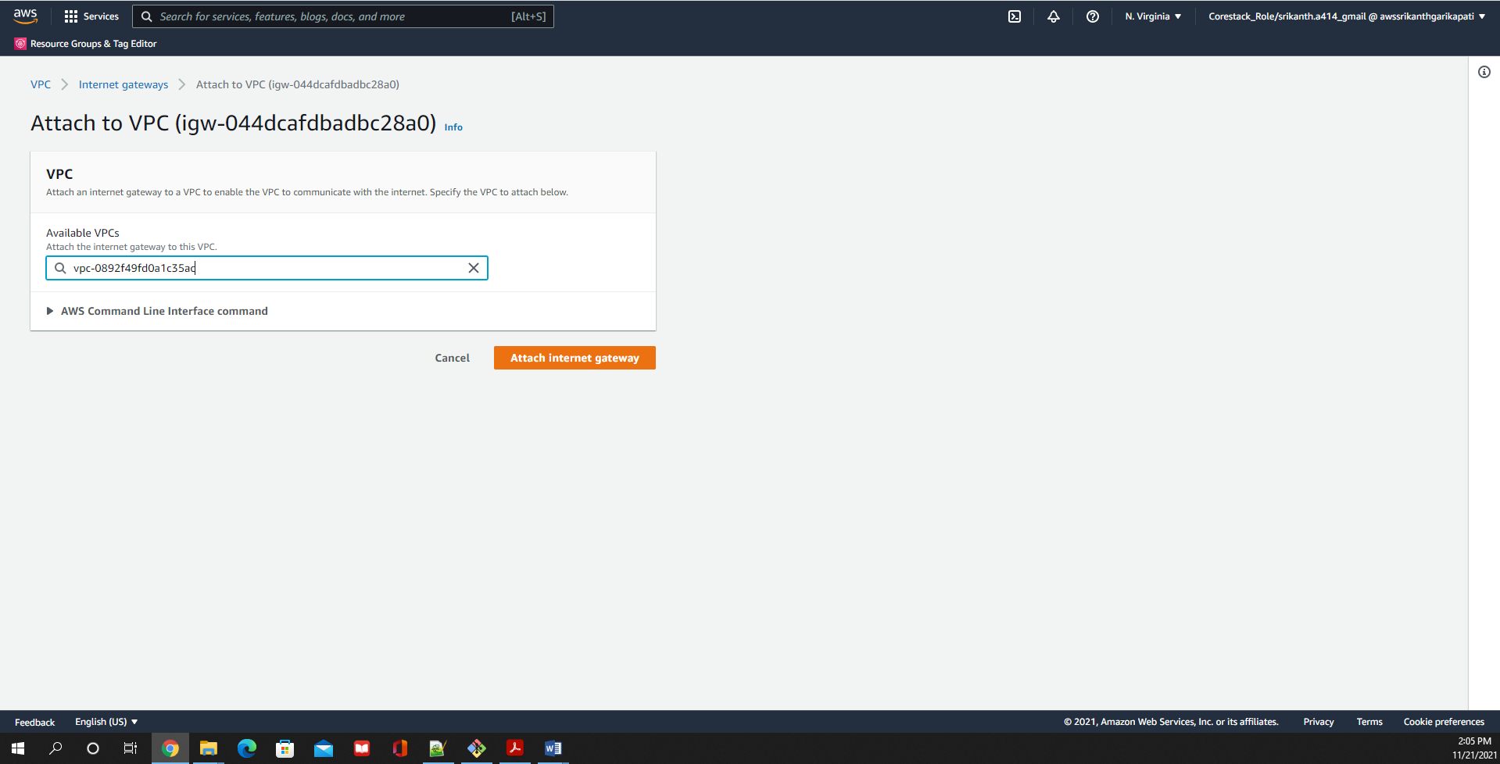

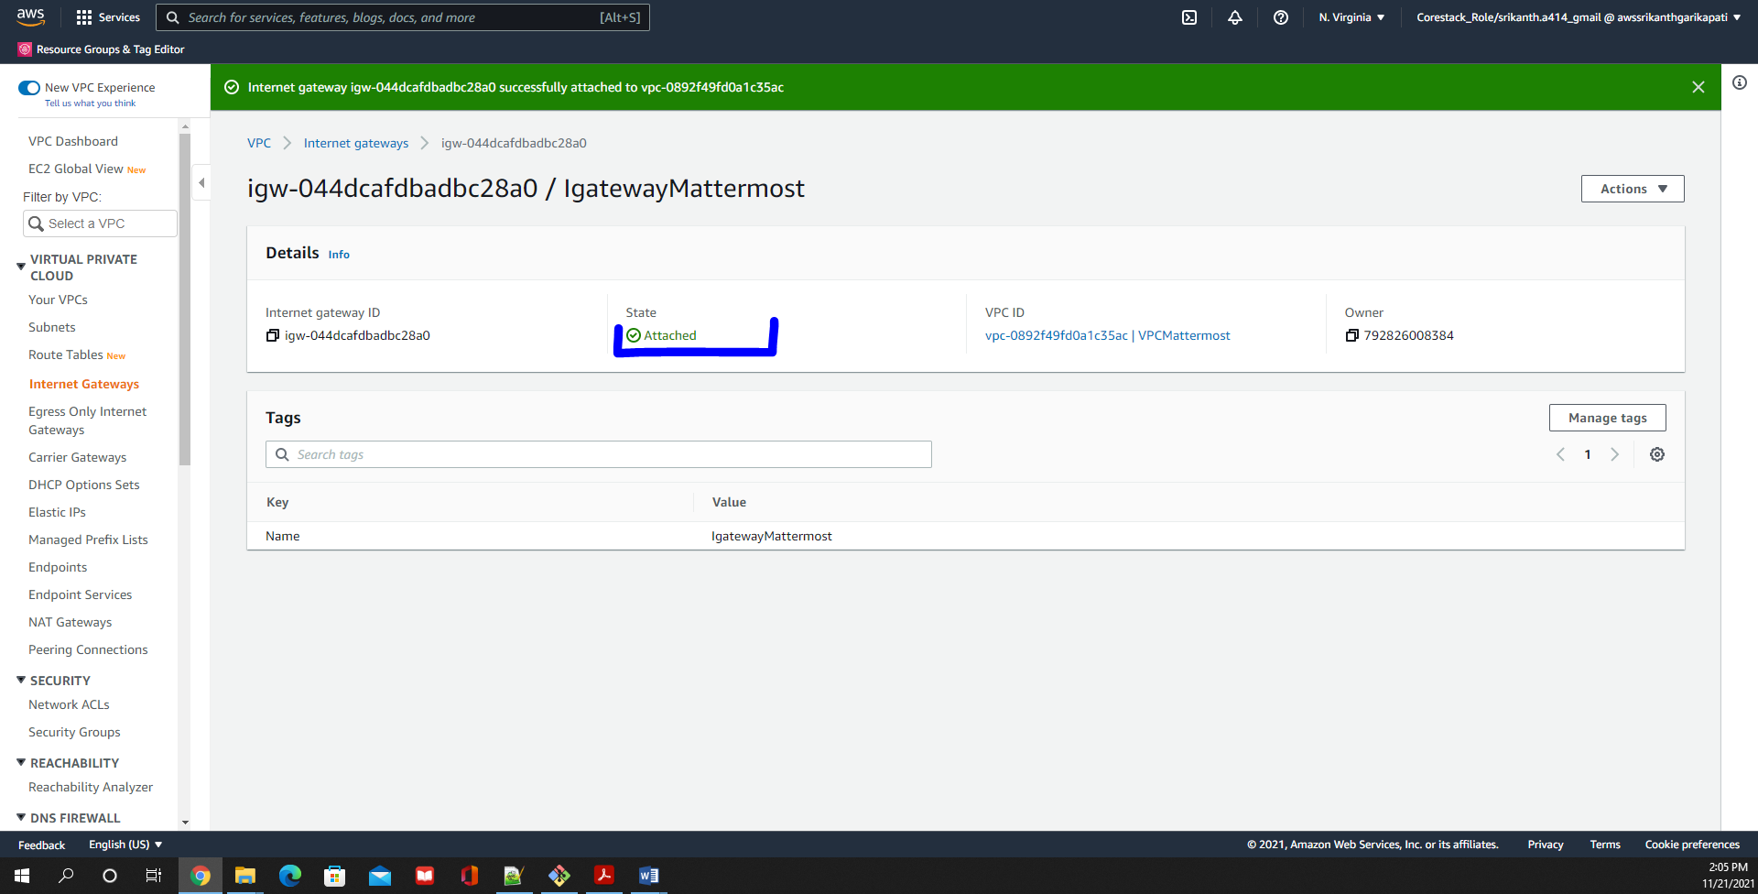

Create 2 subnets ( One Public and One Private )

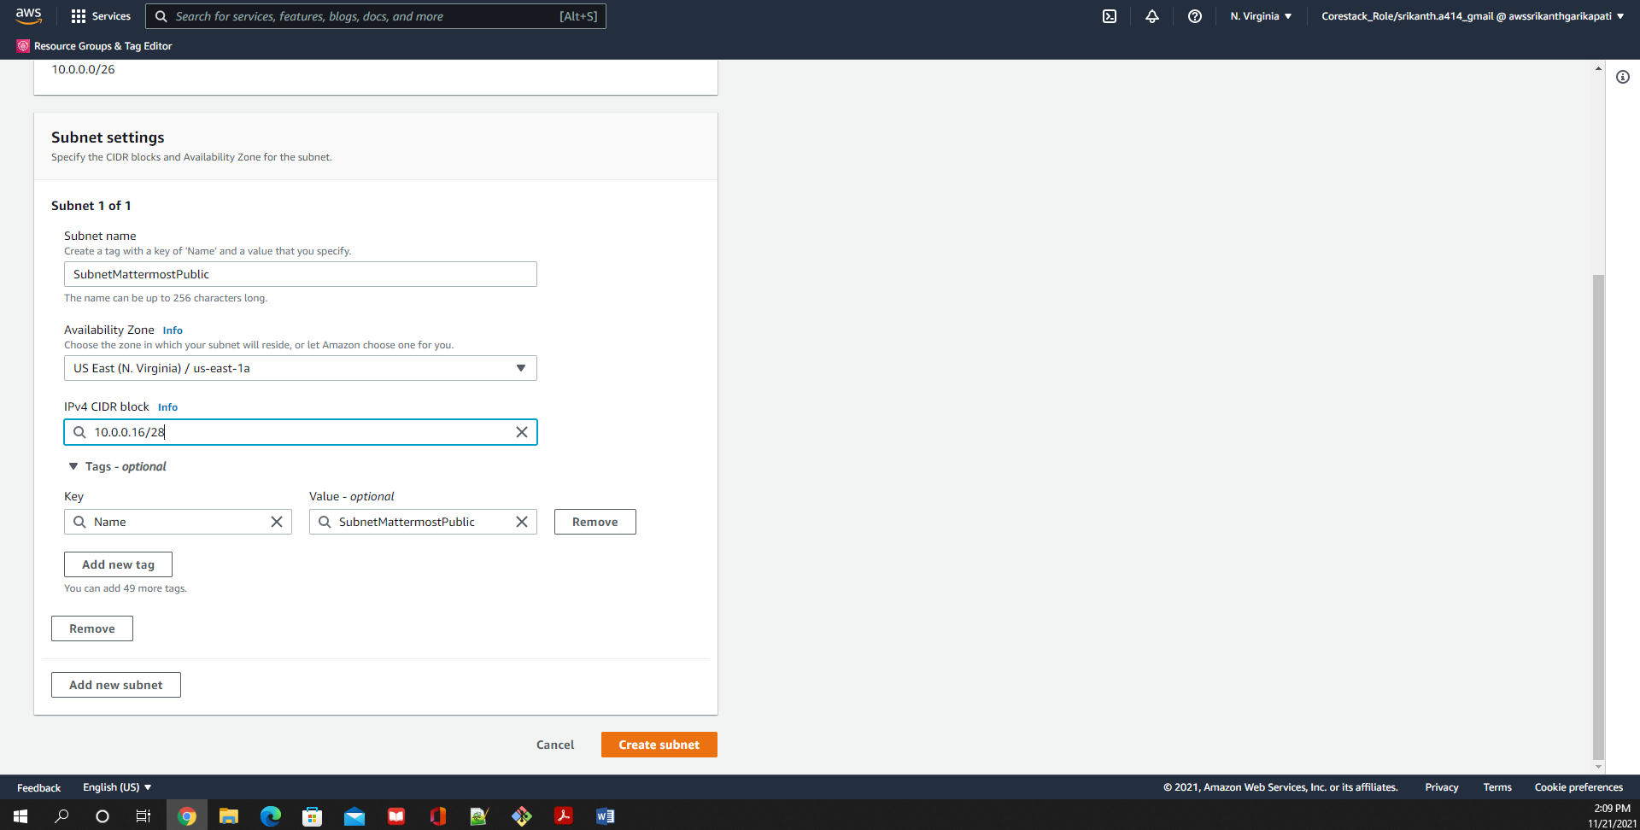

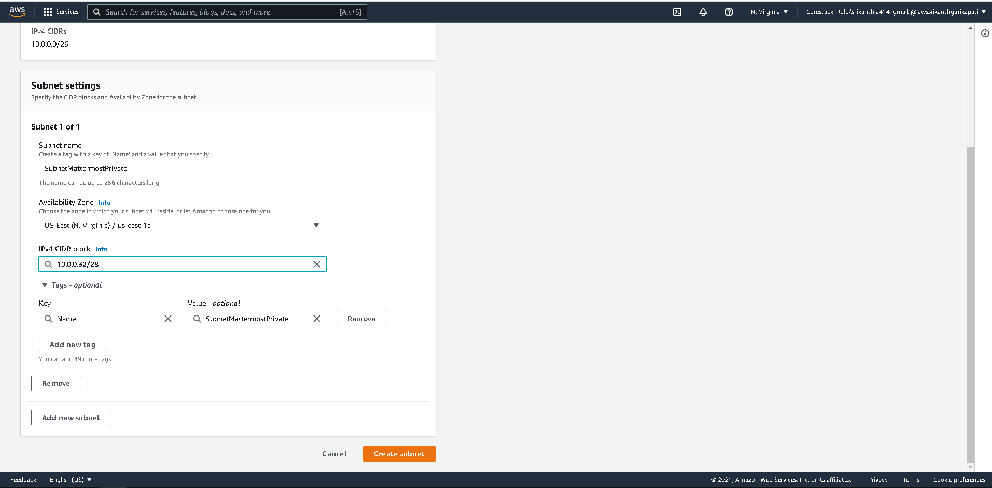

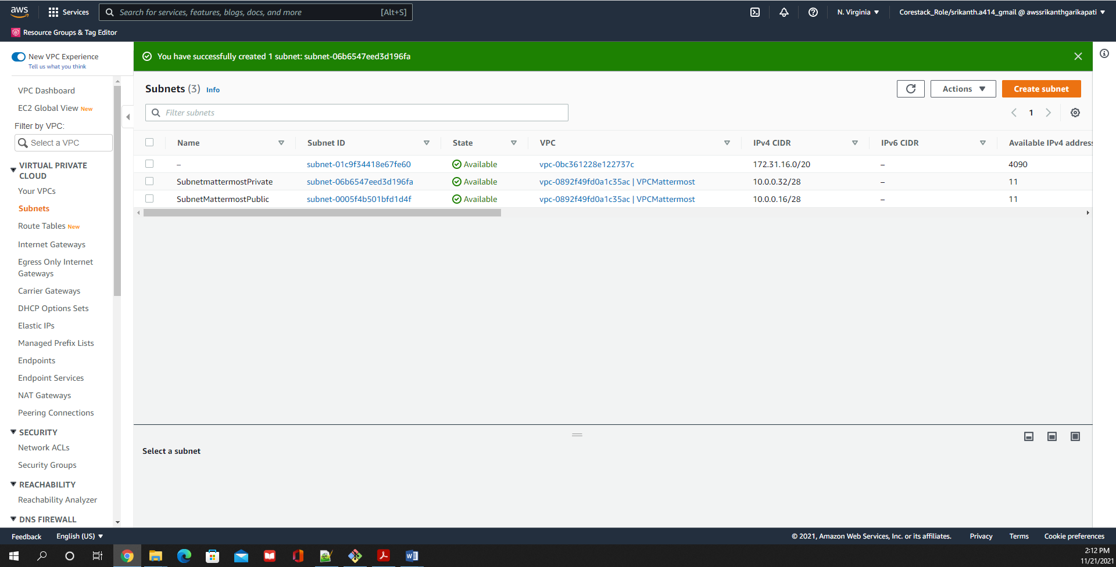

Make Public Subnet Public

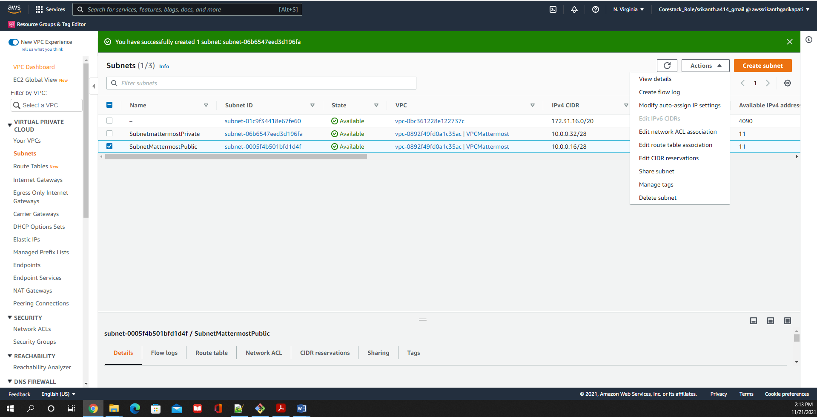

Enable Auto-Assign IPV4

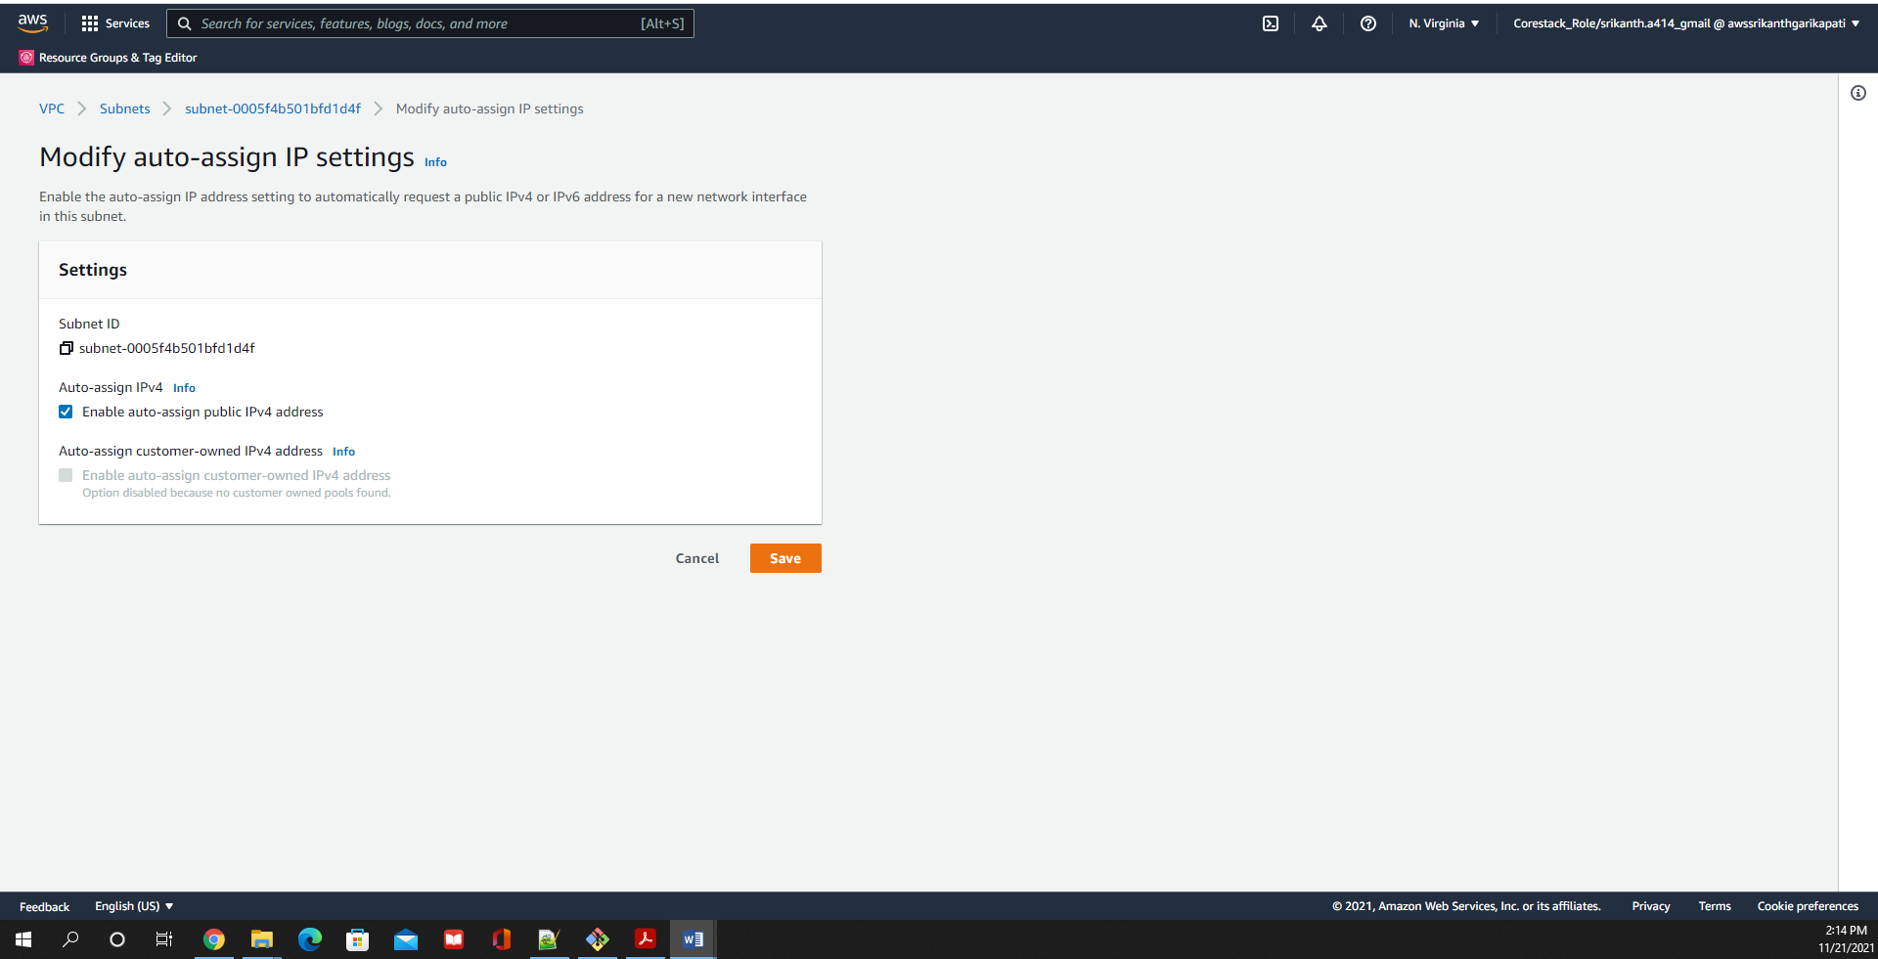

Create Route Tables and attach to Subnets

Create Route Table for Public Subnet and attach to Internet Gateway

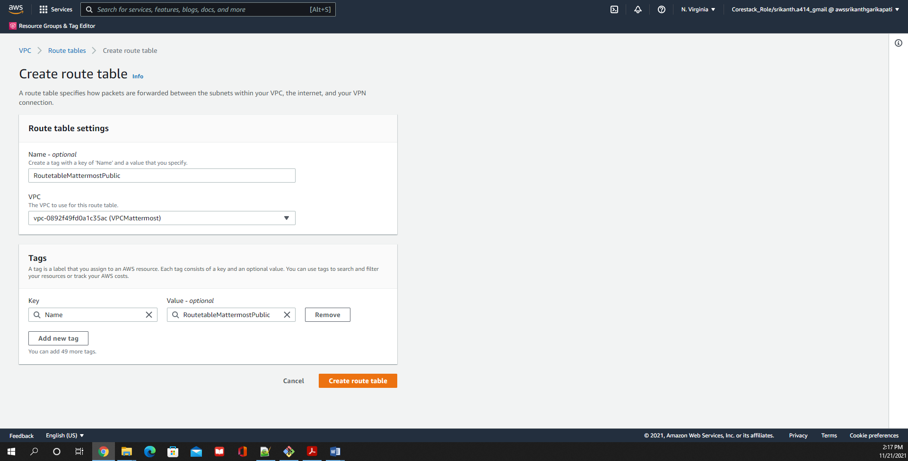

Route Public Route Table to Internet Gateway

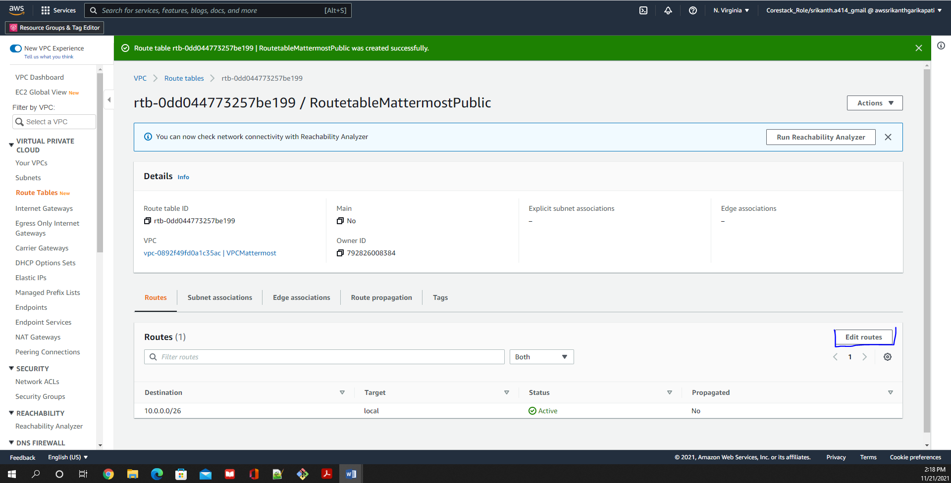

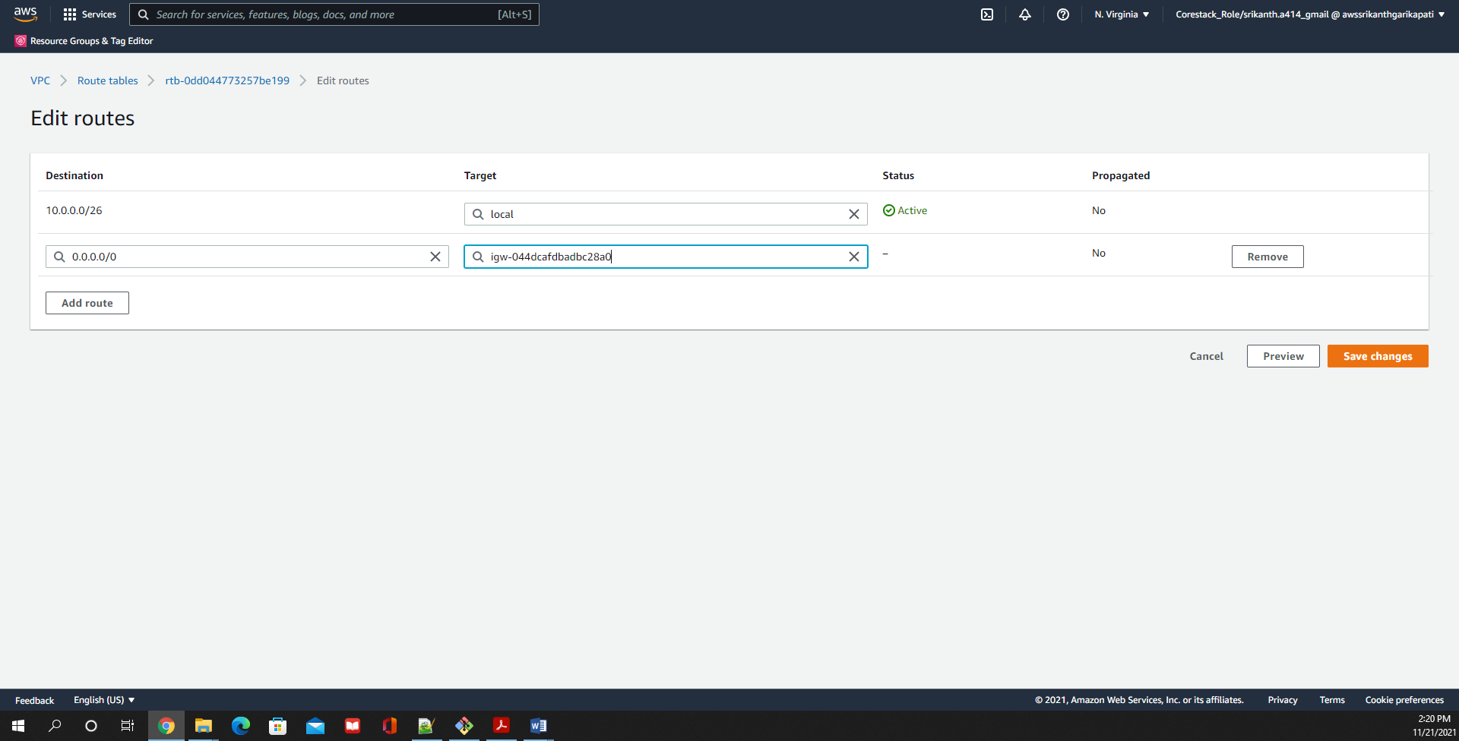

Create Route Table for Private Subnet

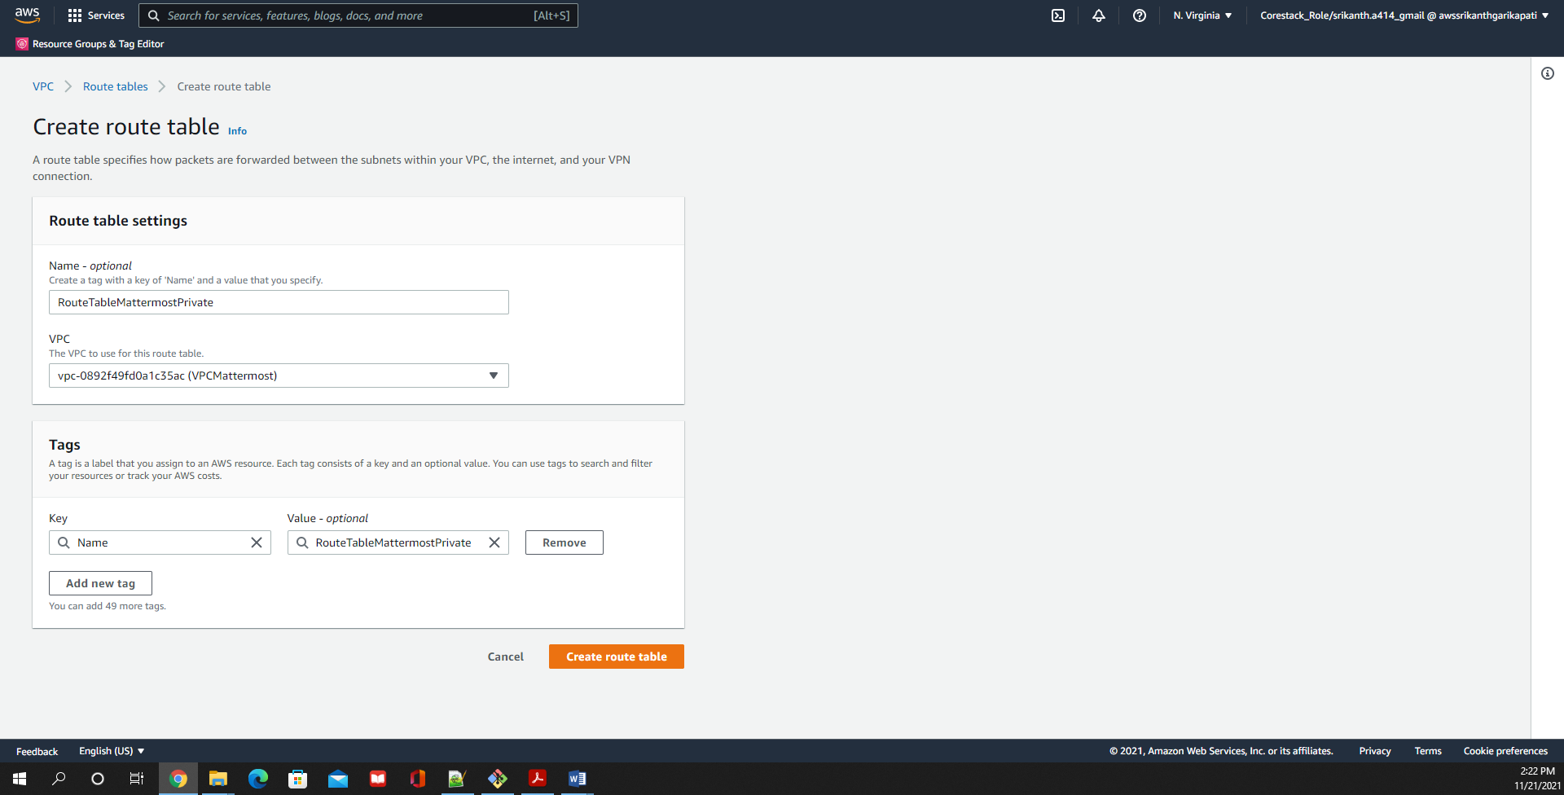

Public & Private Subnets along with Main Subnet are created

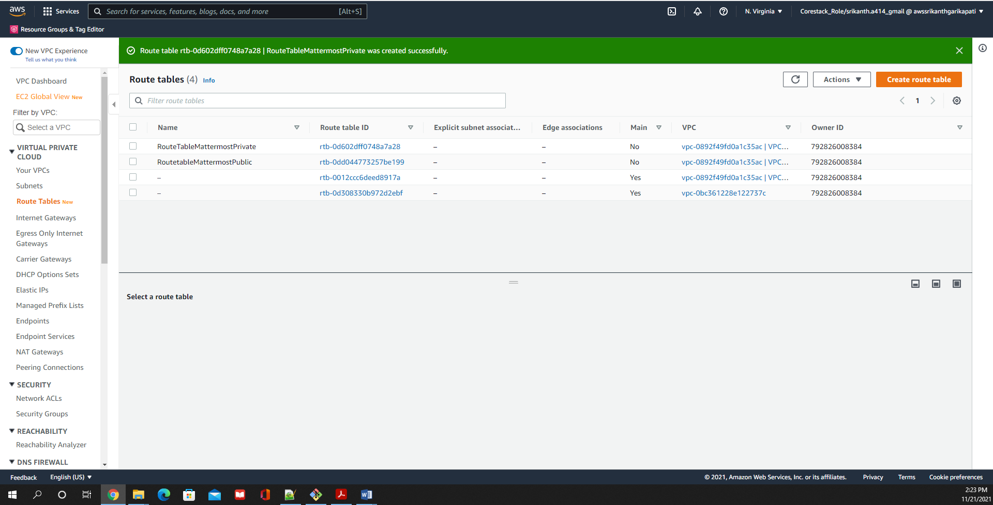

Associate the Route Tables to Public and Private Subnets respectively

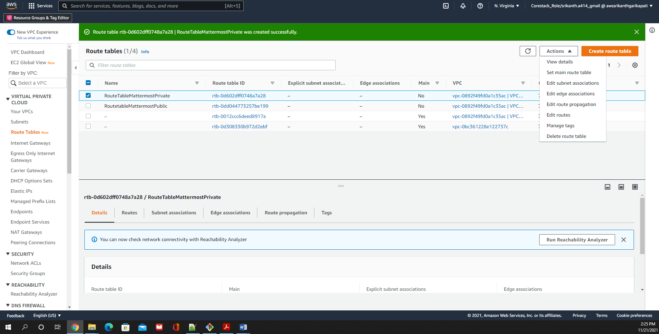

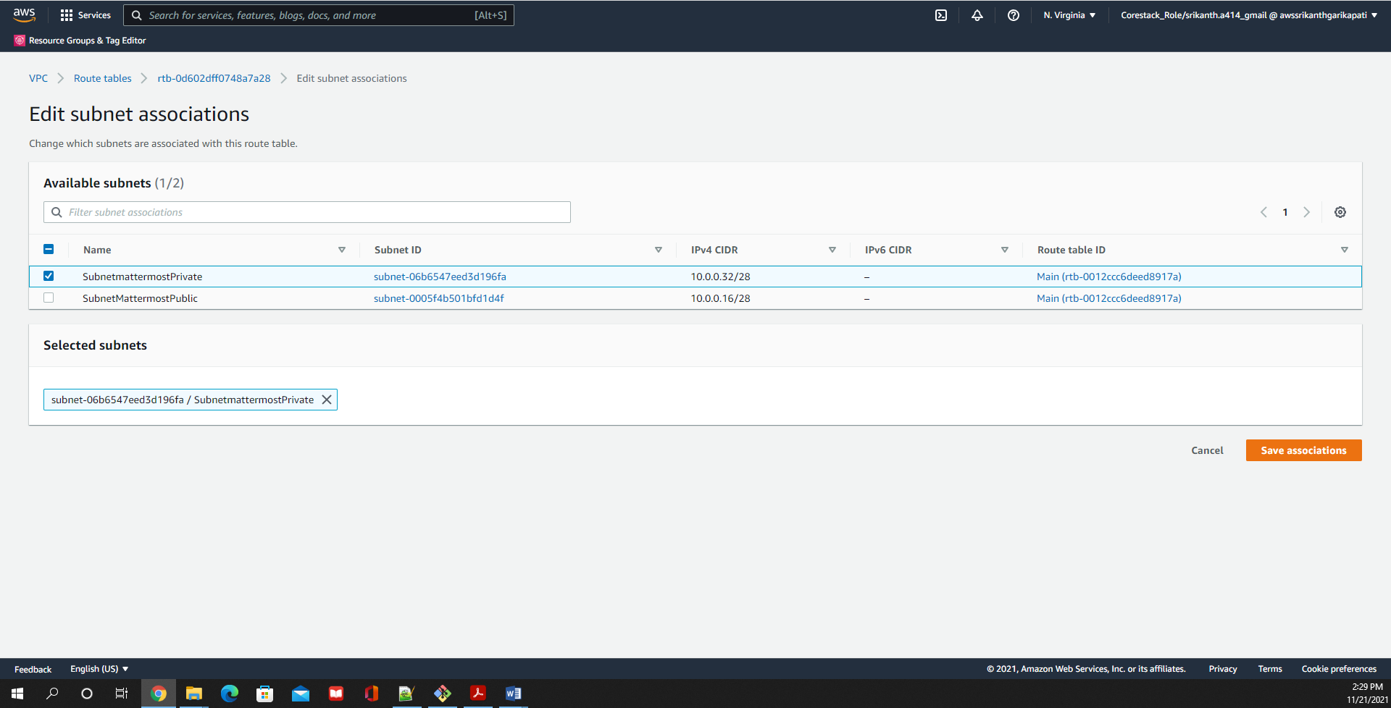

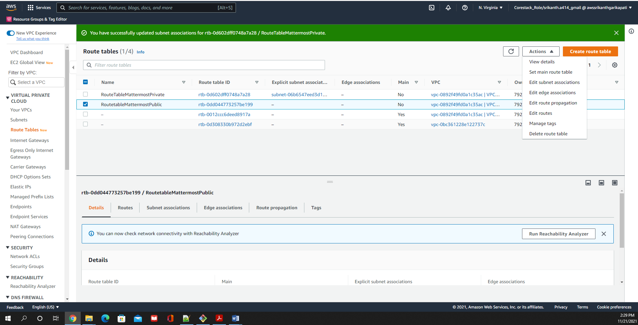

Subnets are associated to route table

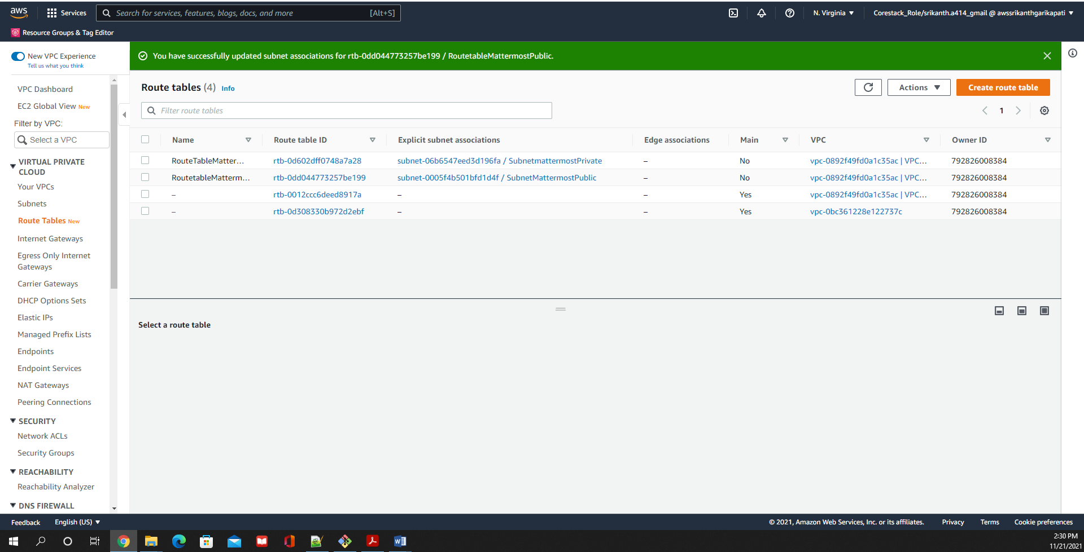

Launch 3 instances

1. Web Instance to host Our Mattermost application
2. DN Instance to host mysql/AuroraDB
3. NAT Instance on Public Subnet

For WebInstance in Public Subnet with UBUNTU 18.04 AMI

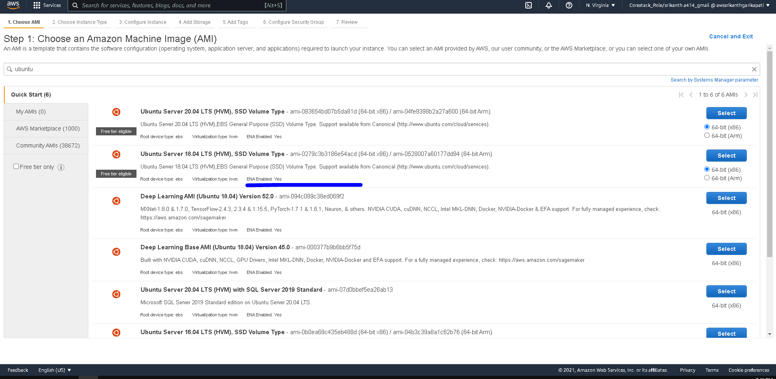

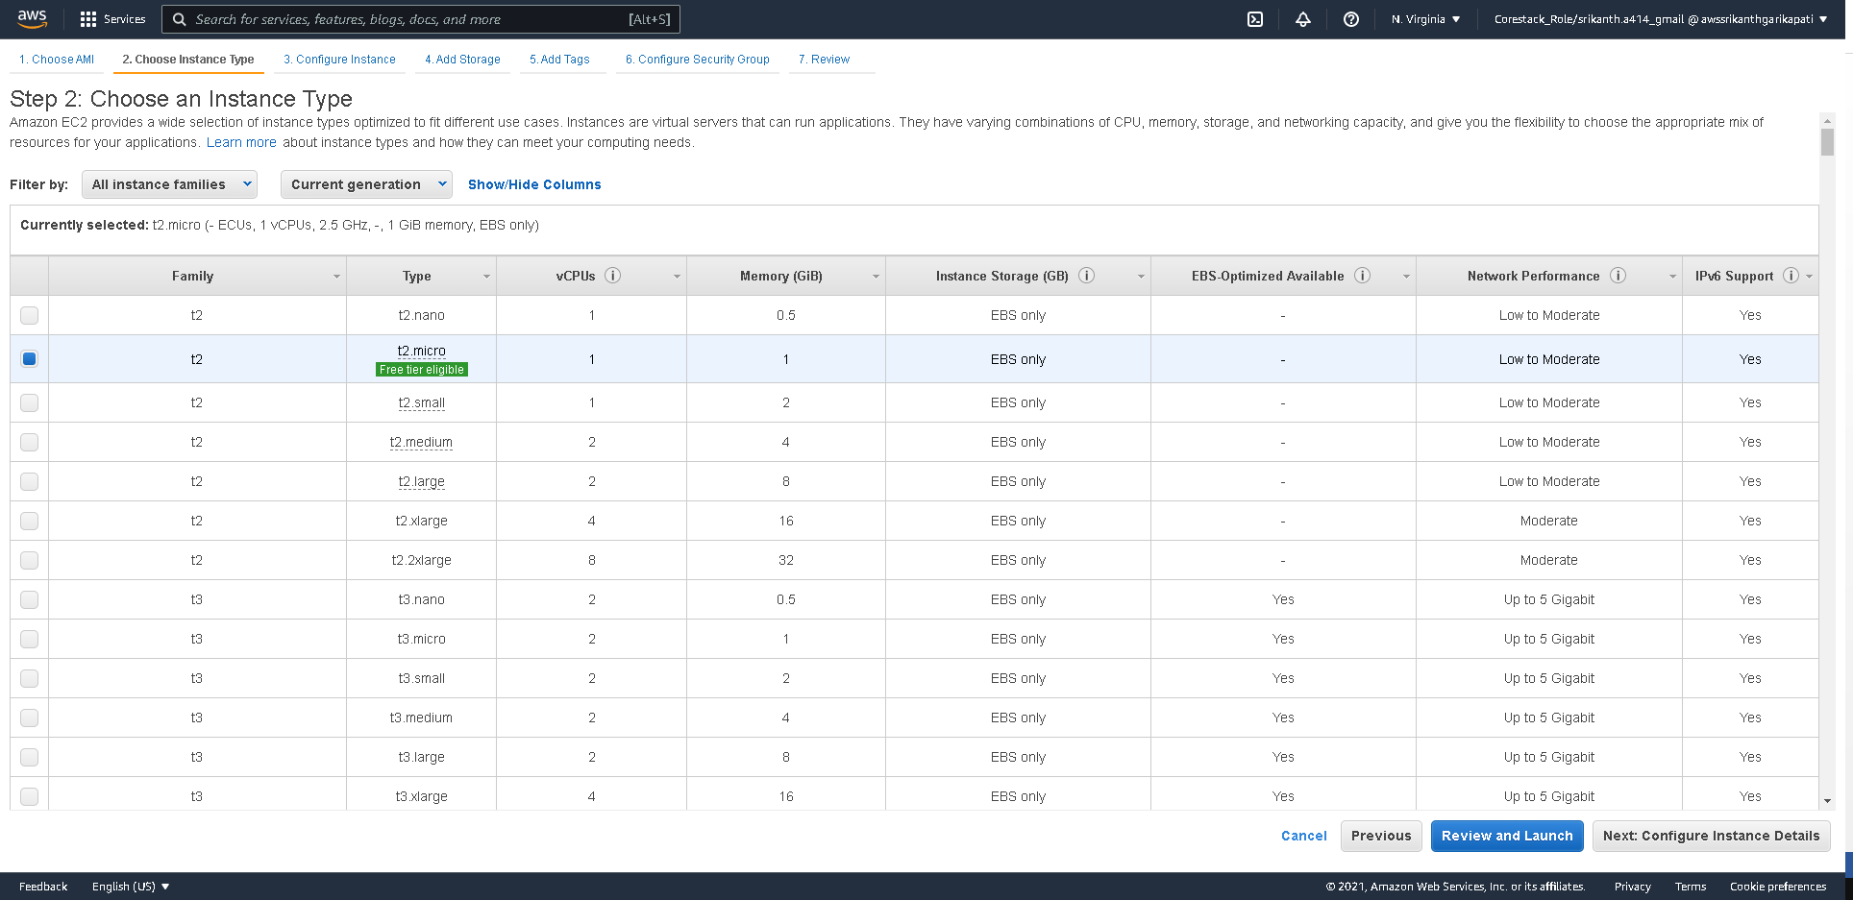

Make sure to launch WebInstance In Public Subnet

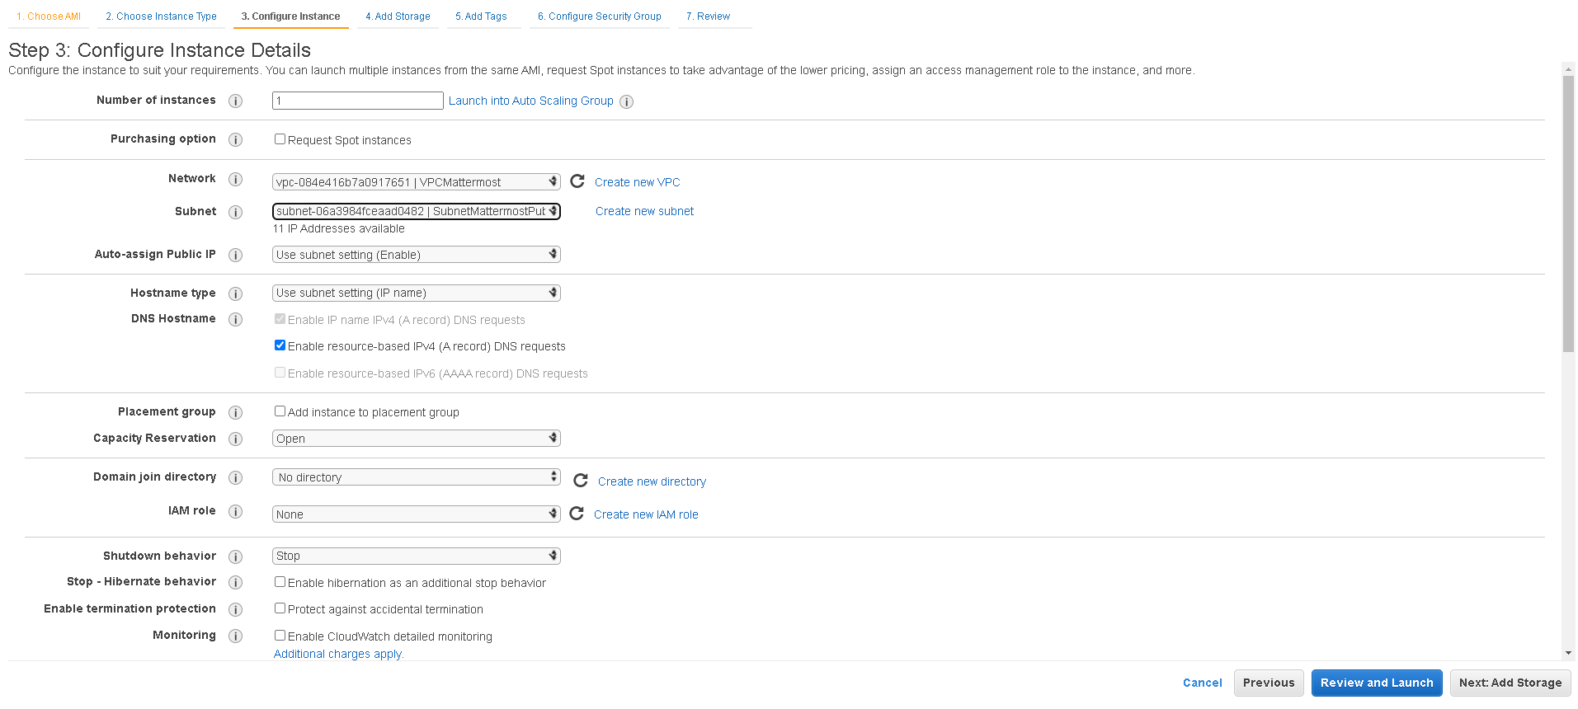

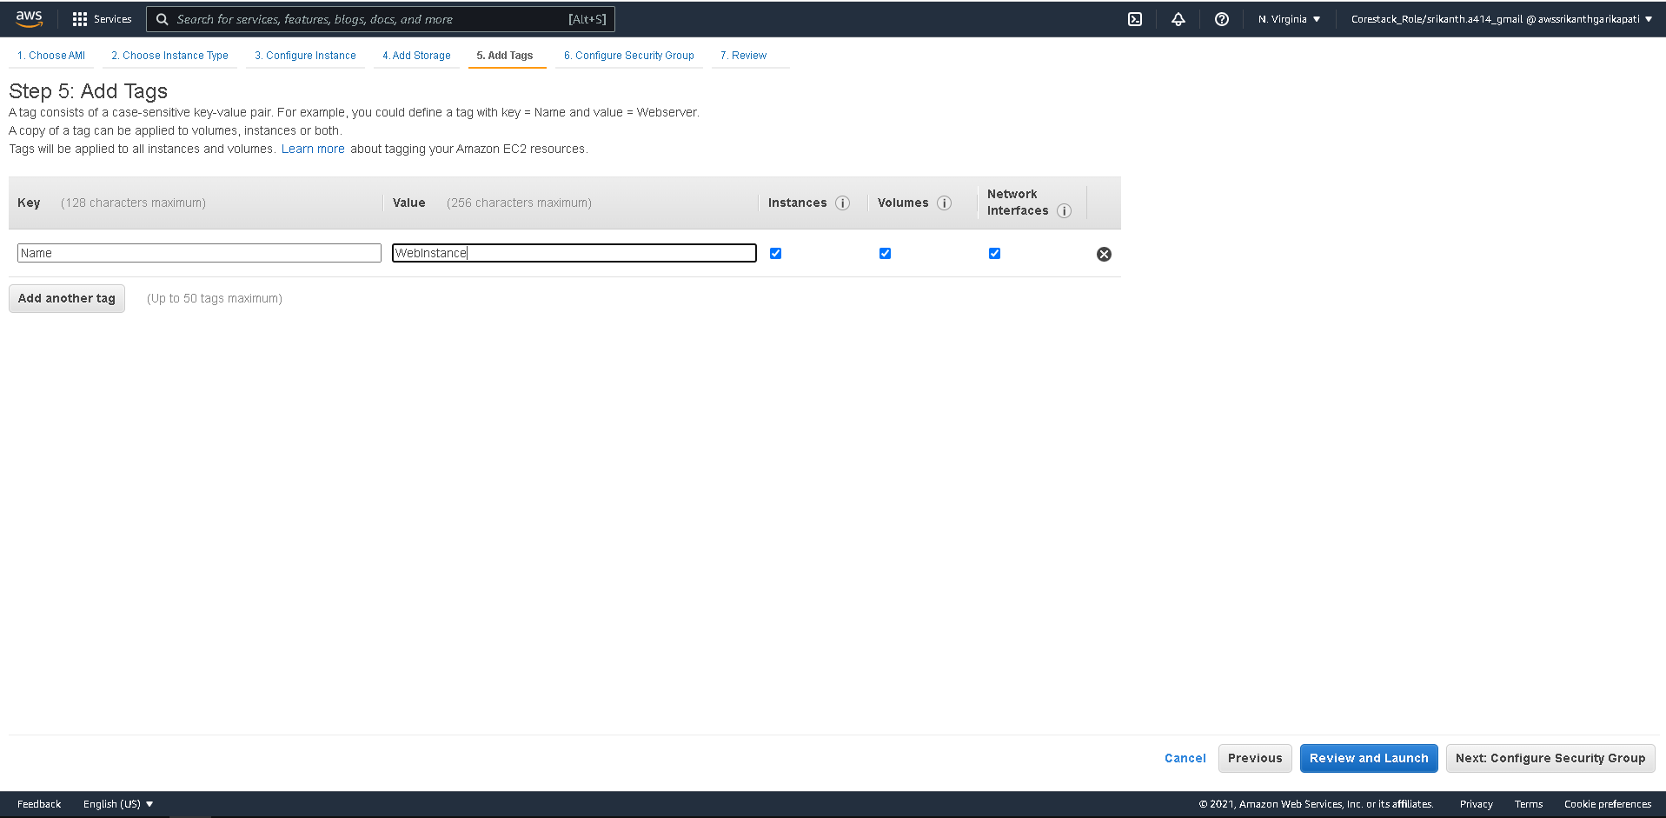

Configure a new Security Group Matter most Application on this Web-instance to listen to Port 8065

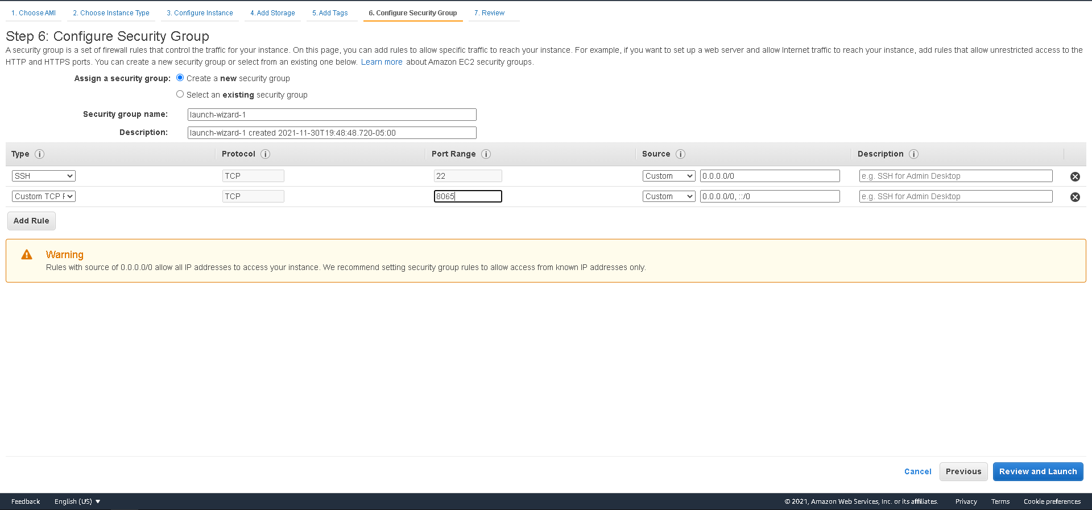

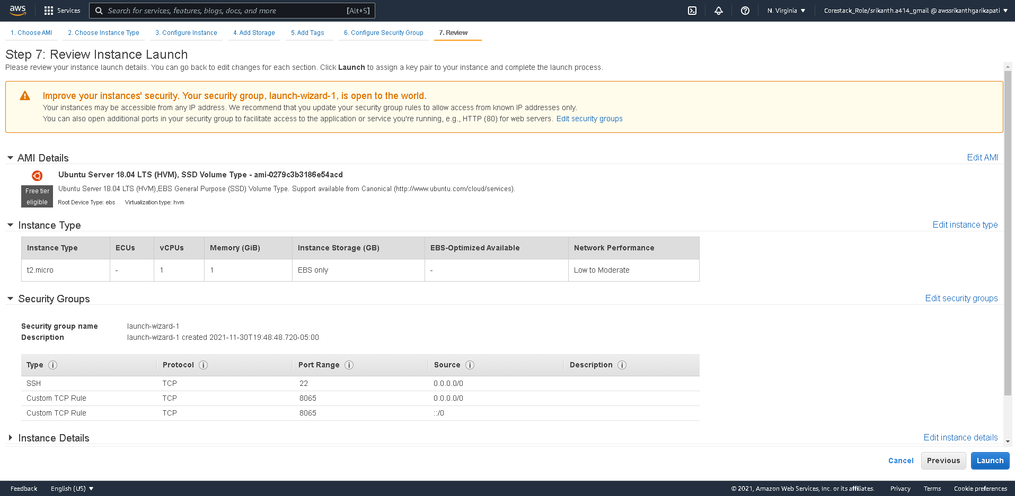

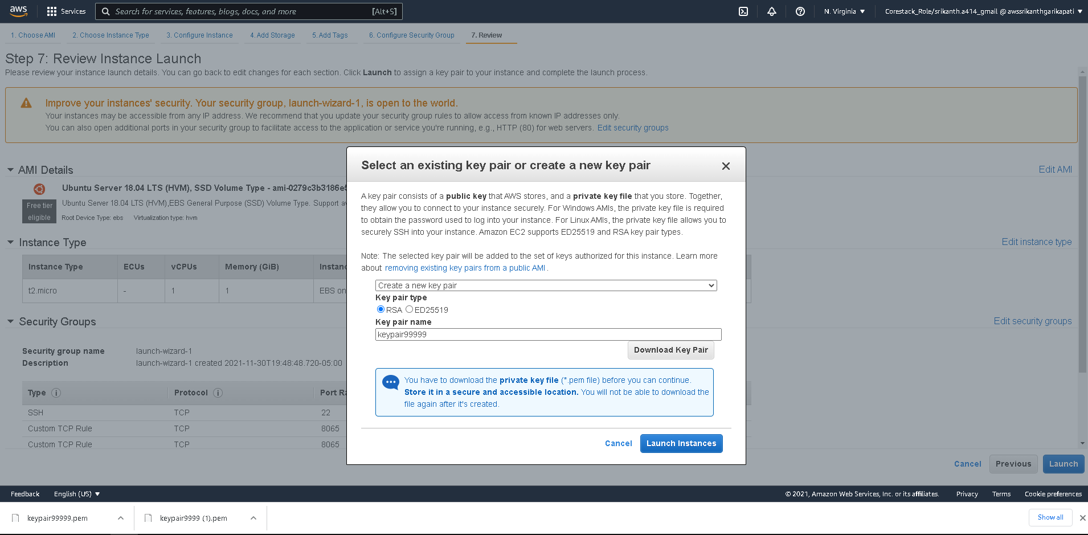

Launch DB-Instance in Private Subnet

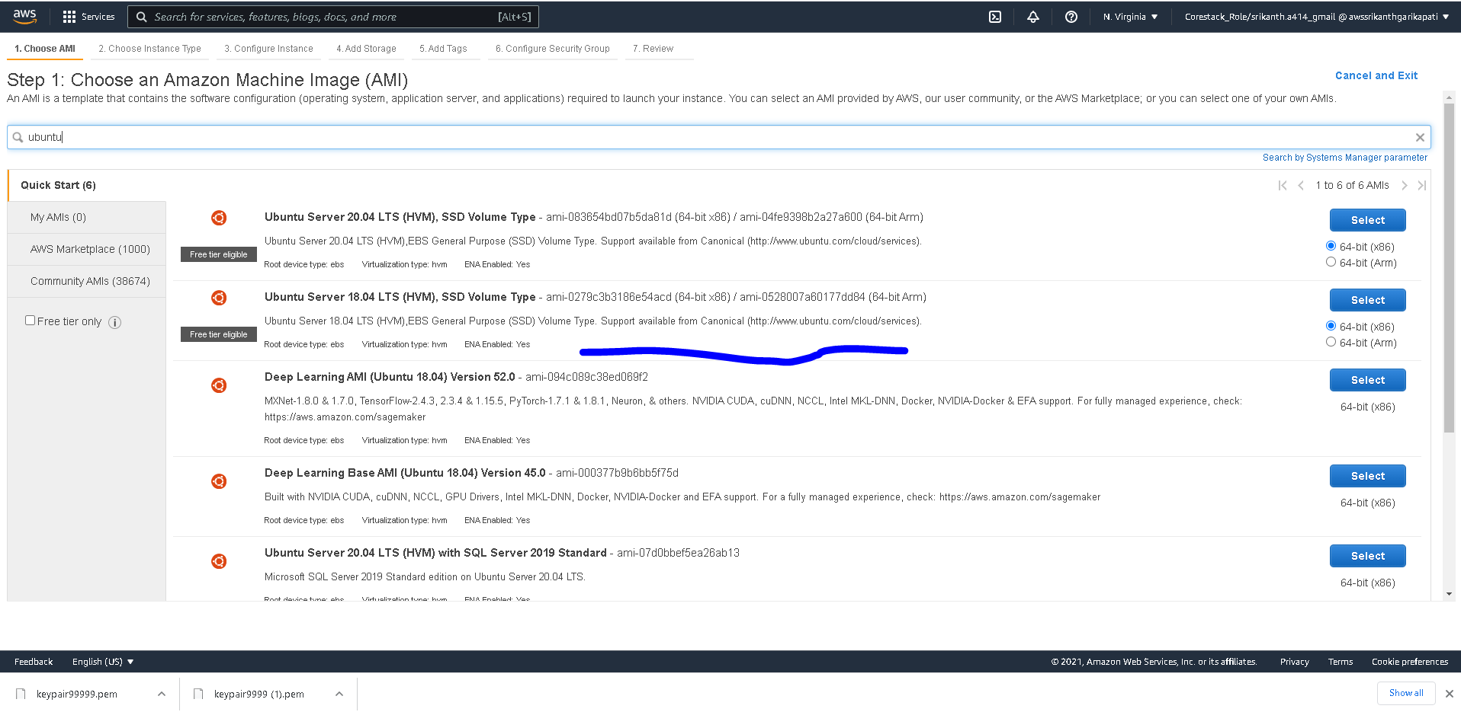

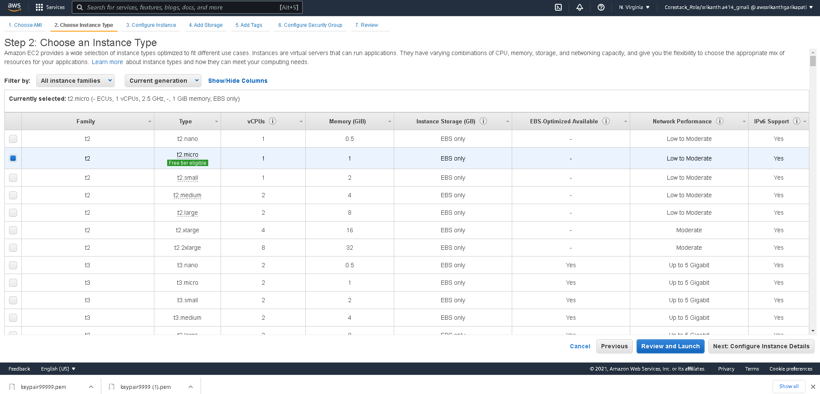

Make sure to select the Private Subnet with Public Ip disabled

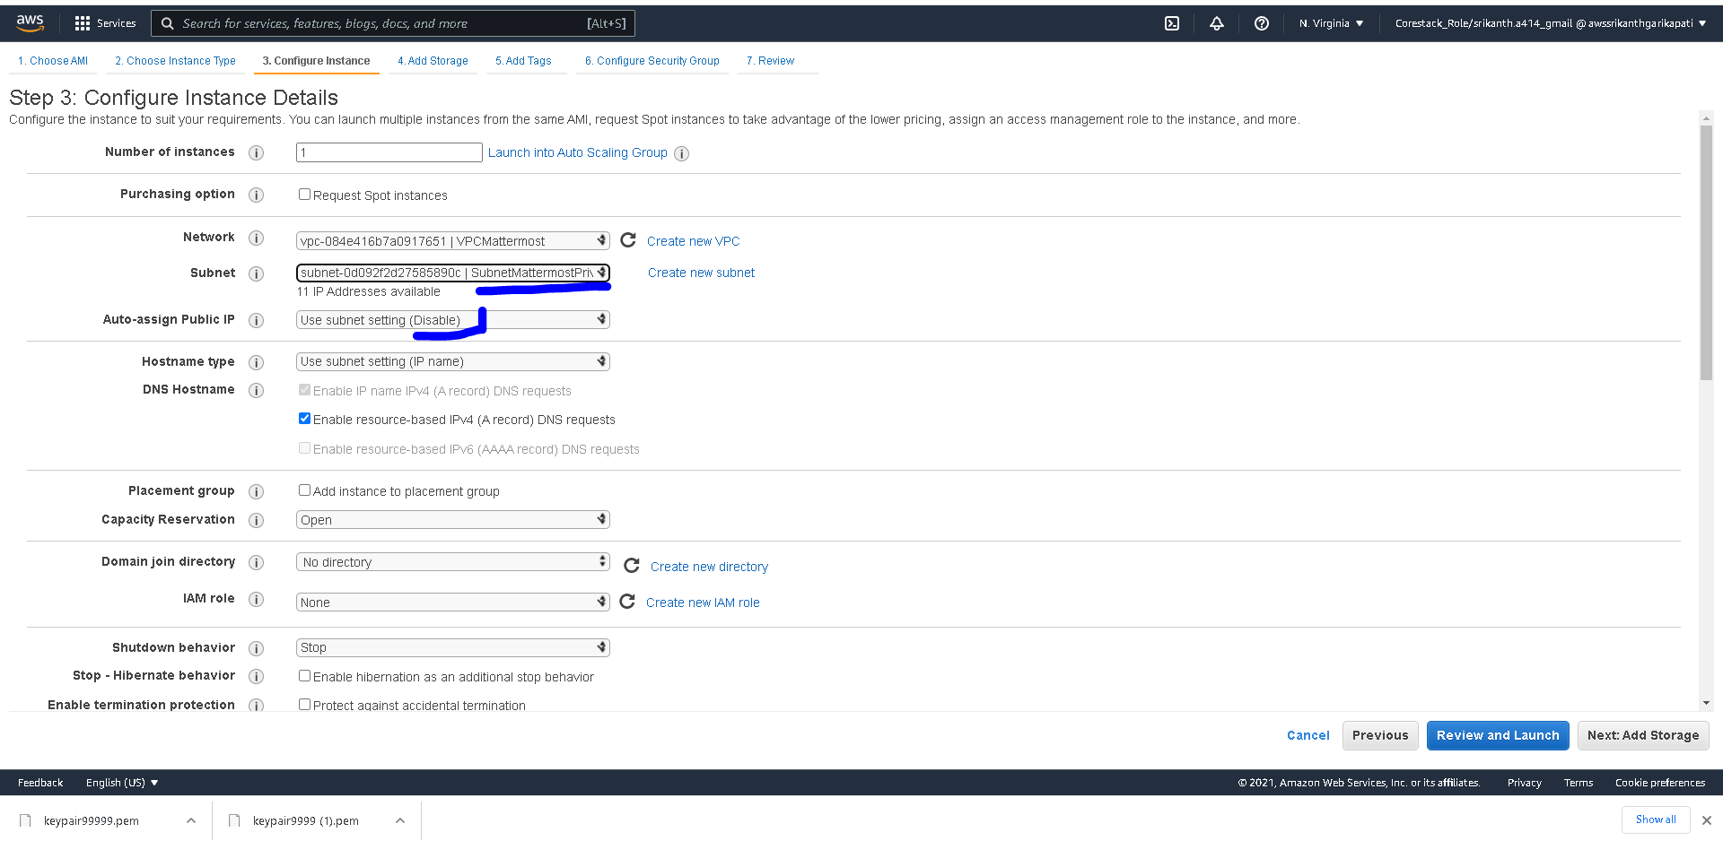

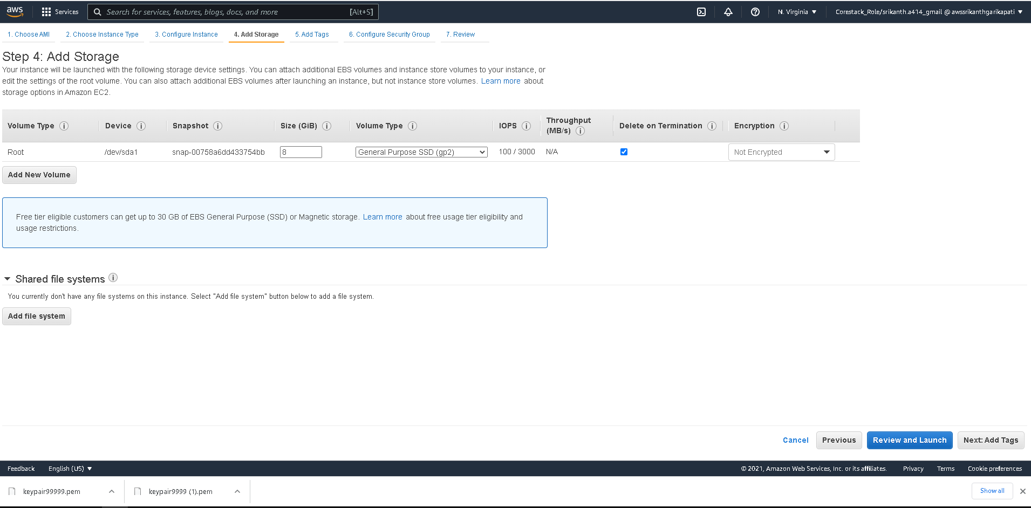

Create a new Security Group for DB instance CIDR range of Public subnet is mentioned as the source

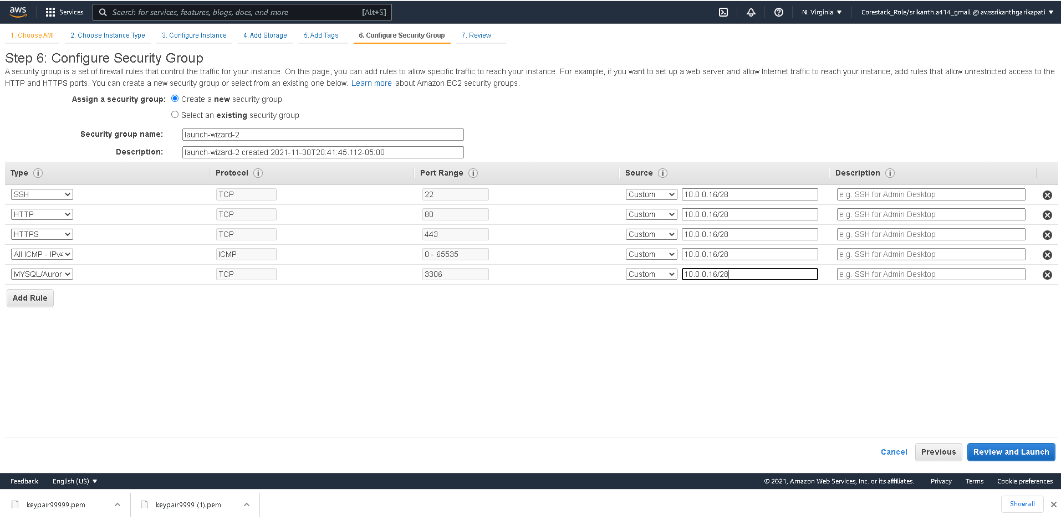

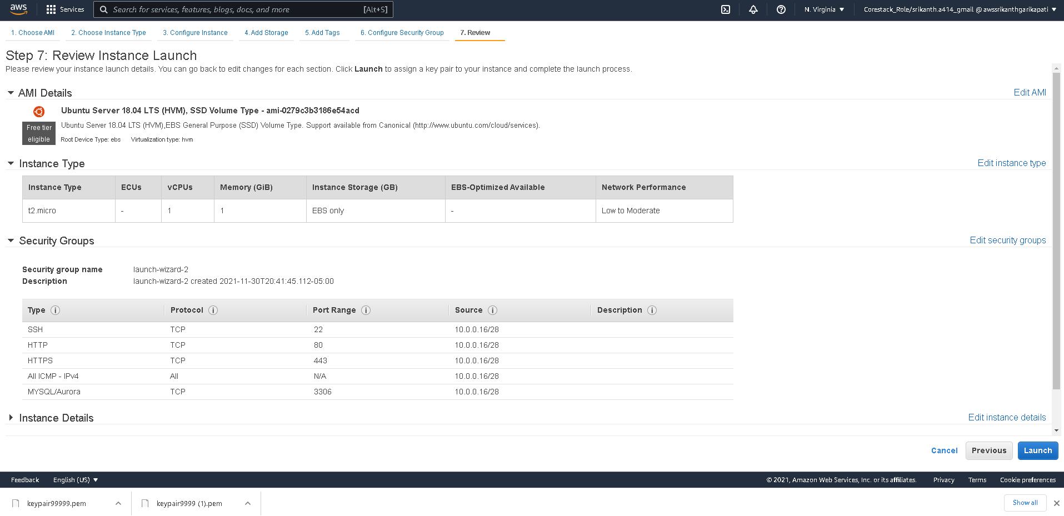

Launch NAT instance by select community AMIs and selecting NAT specific AMI

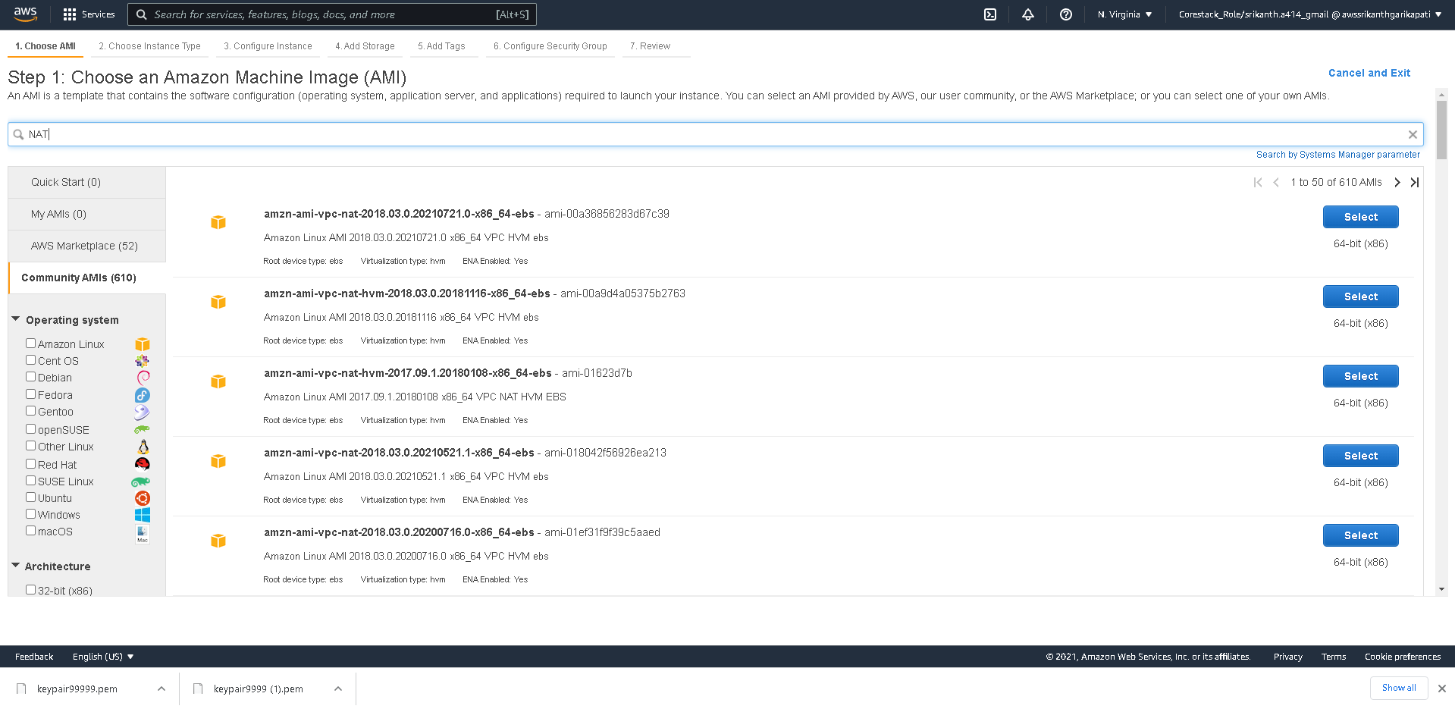

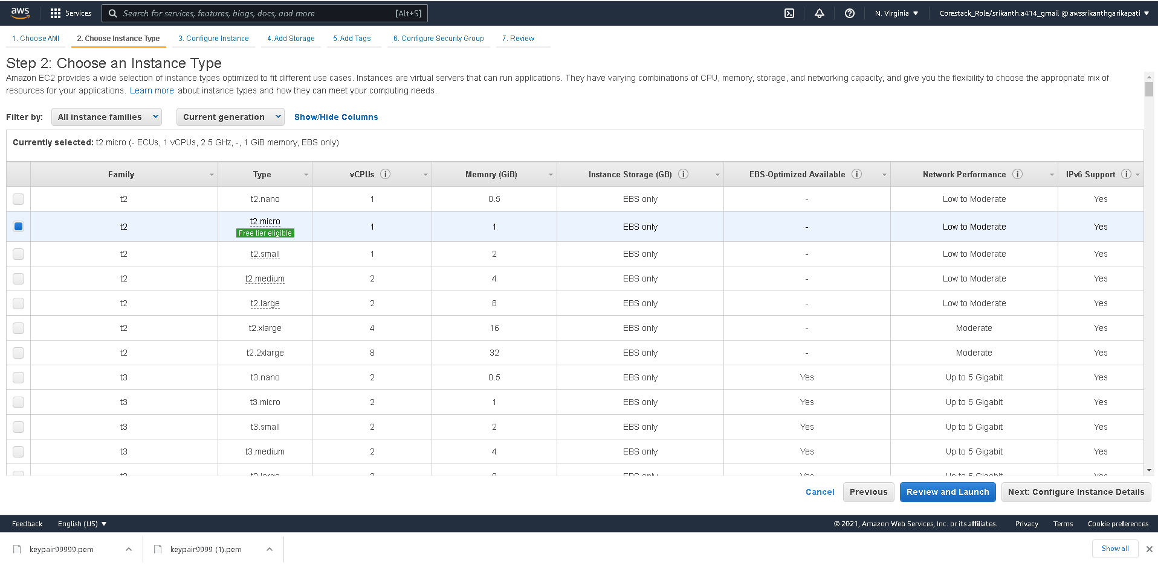

Create NAT instance in the Public Subnet

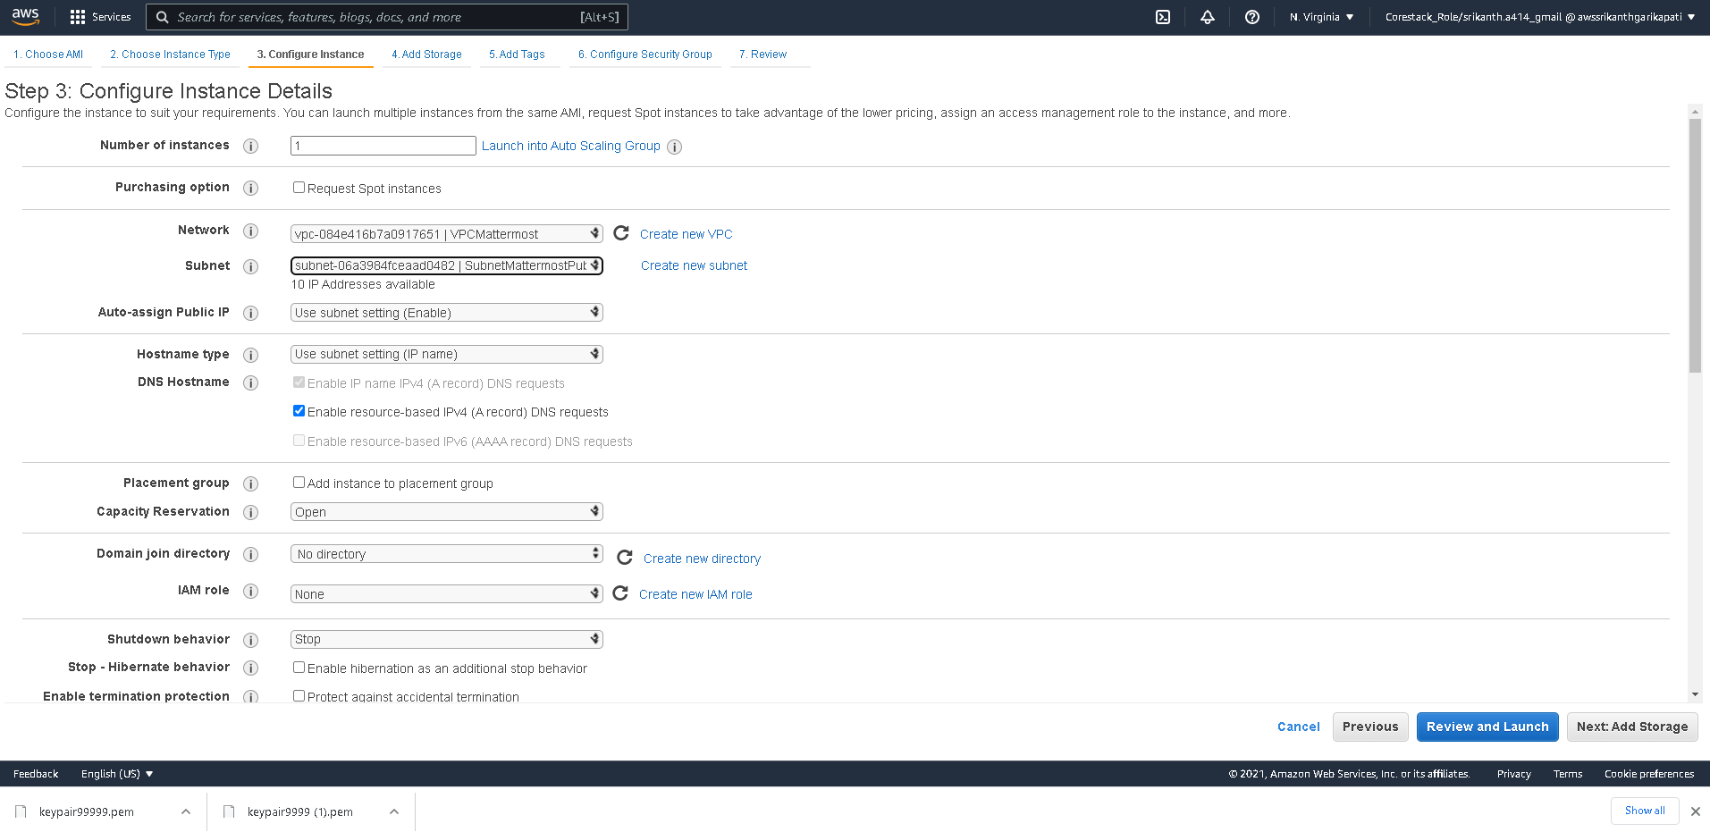

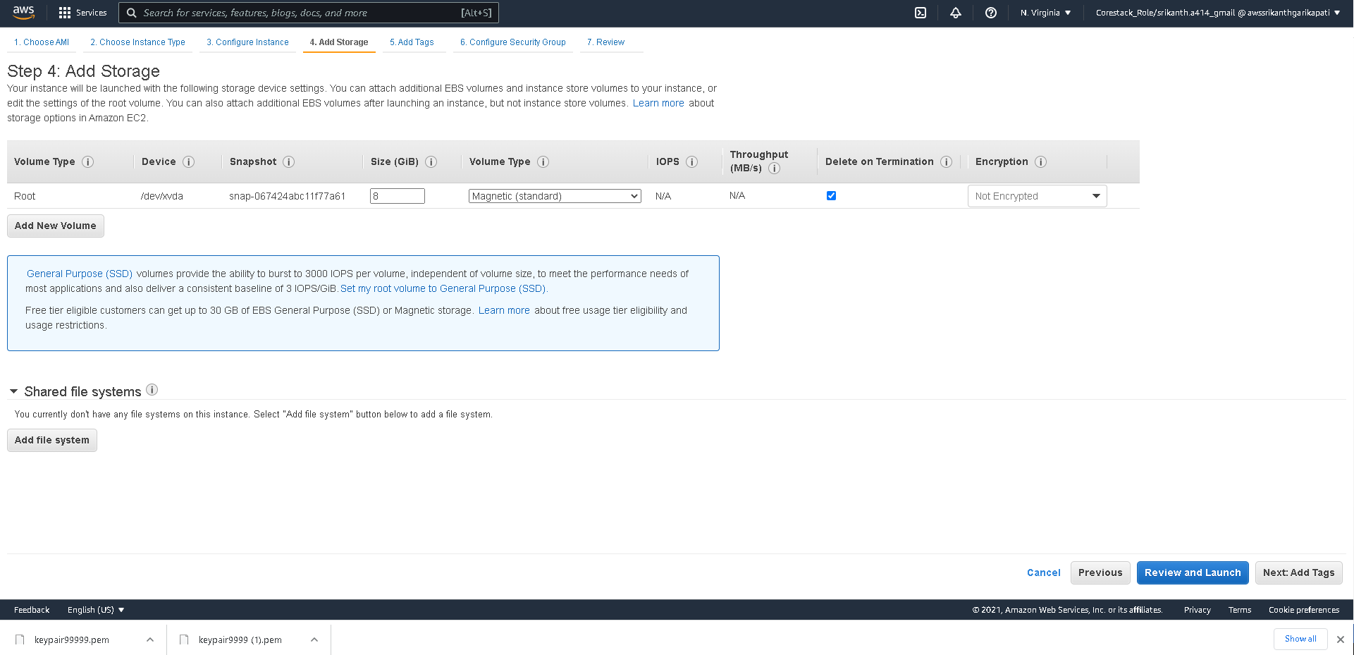

Name your Instance

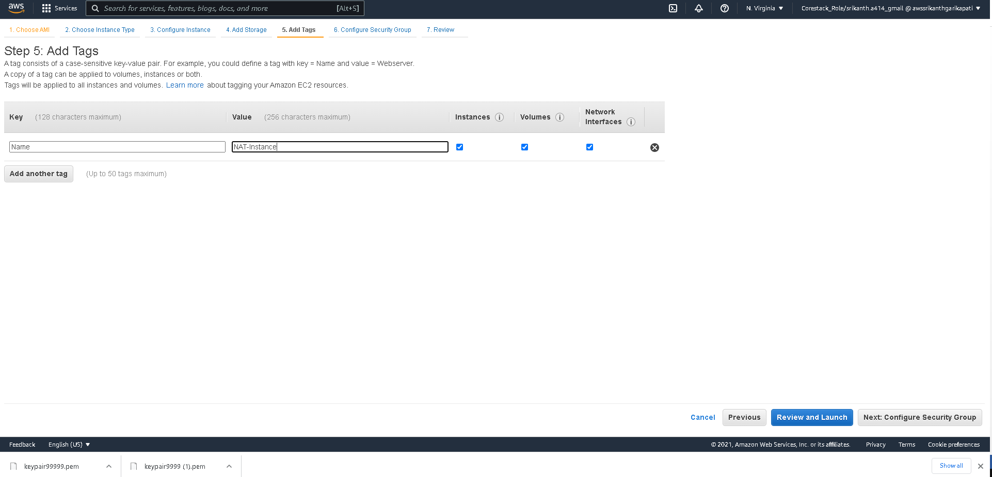

New Security Group for this NAT instance

1. Traffic inflow from private subnet – to interact to the internet
2. Traffic inflow from within the public subnet with port 80,443 is specified which means that the NAT instance is acting as a firewall instance for the traffic inflow for both Public and Private Subnet

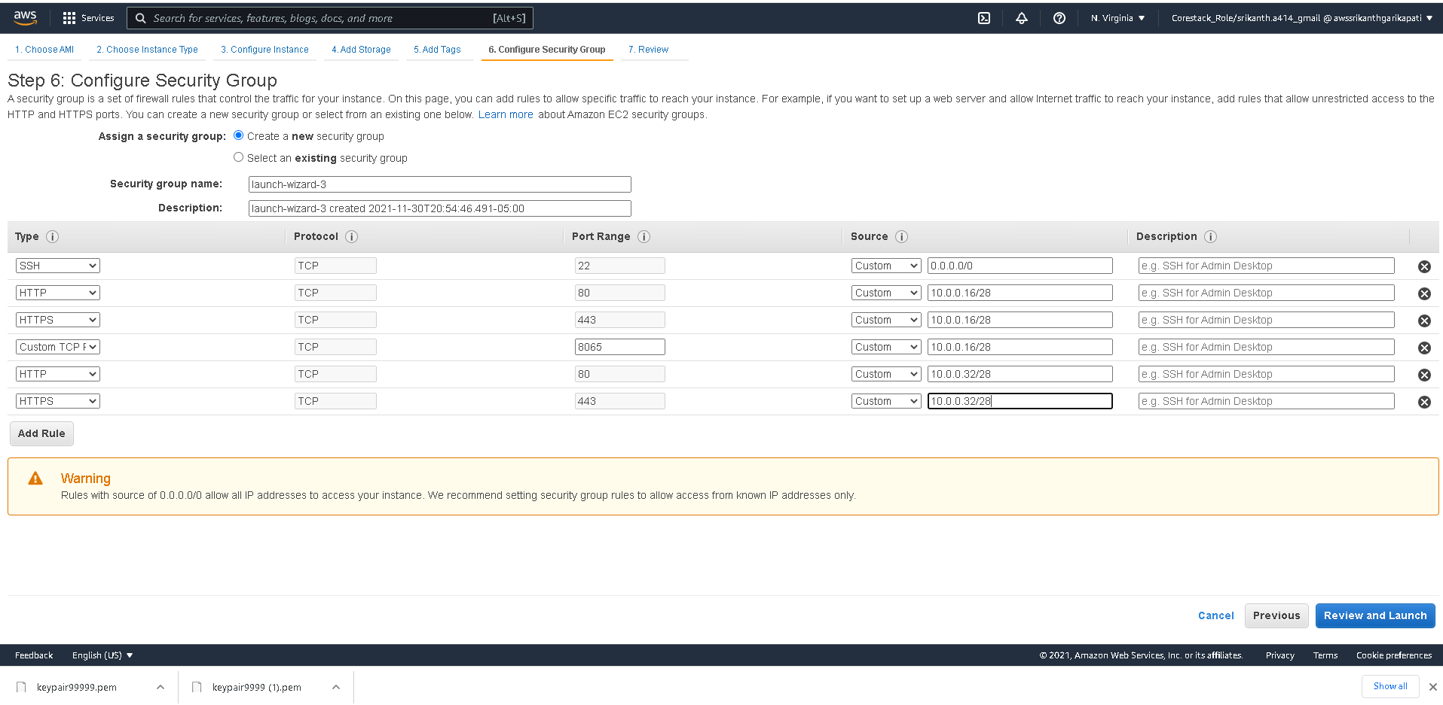

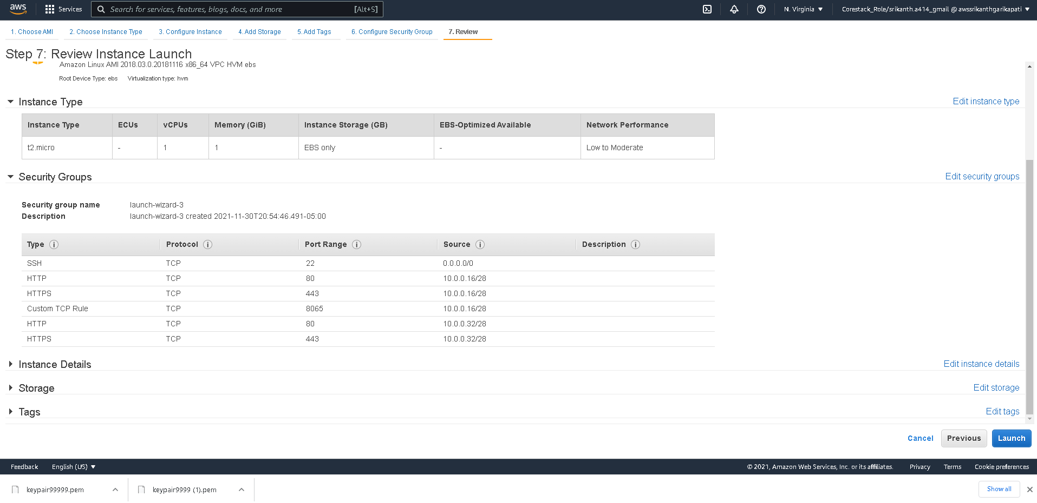

Select NAT instance and Disable source and destination check

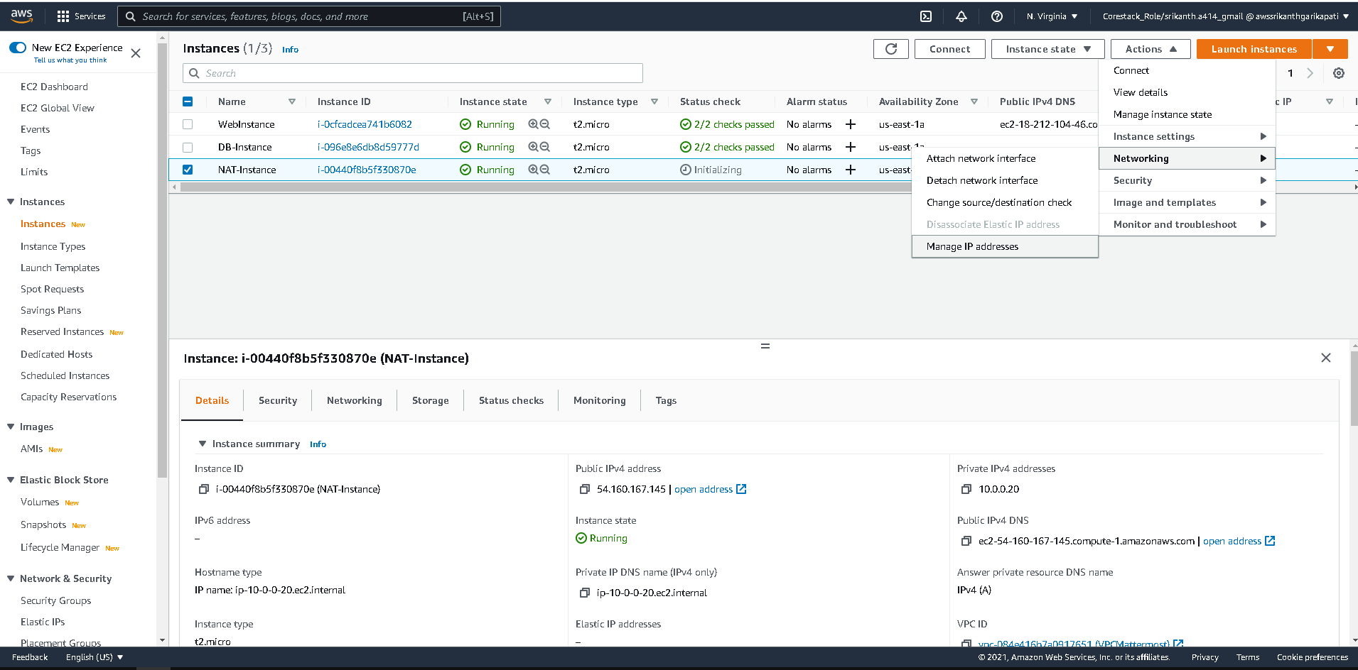

Click on Routes of Private RT and set destination as ‘0.0.0.0/0’ and set the Target as NAT instance.

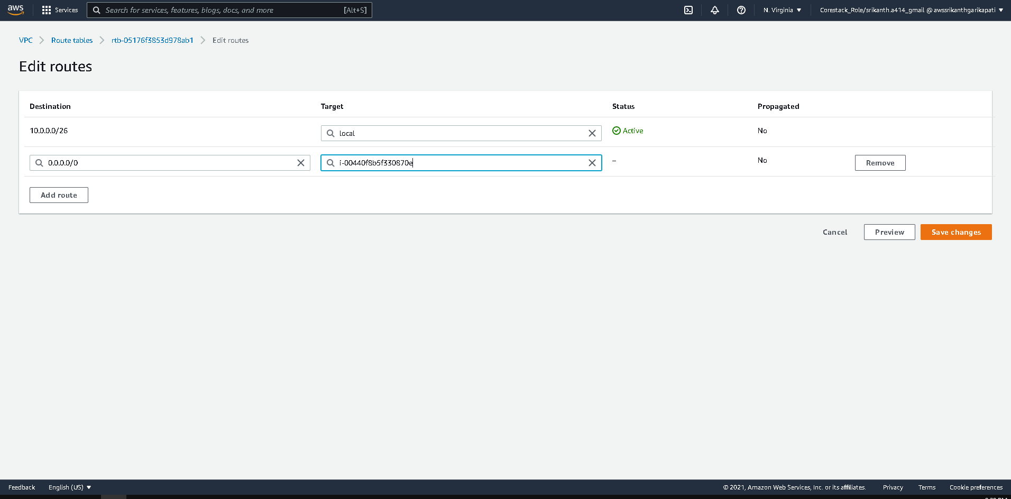

Main RT ( Default RT Launched with VPC ) also gets the route to NAT, same like private RT

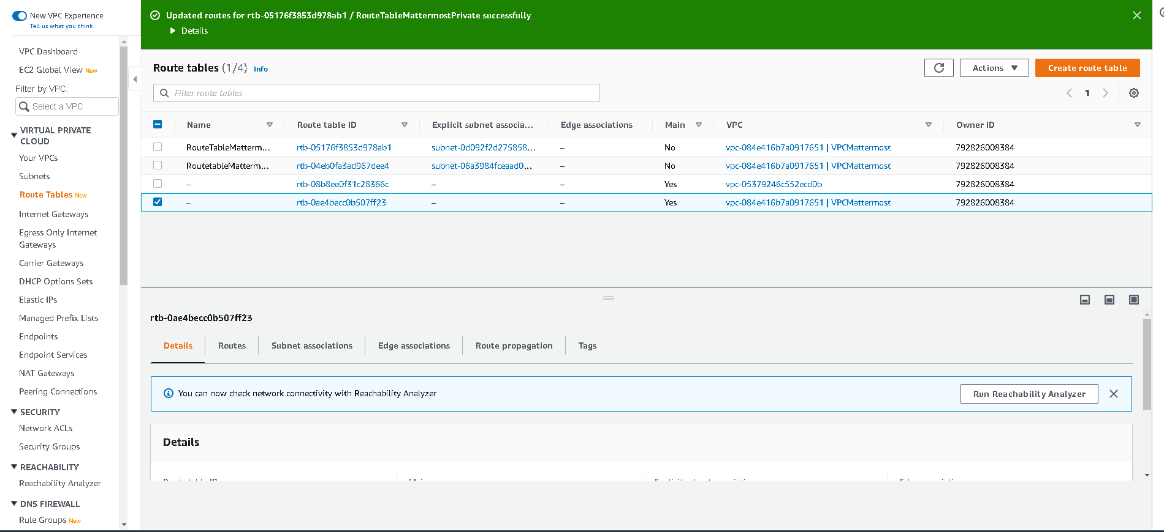

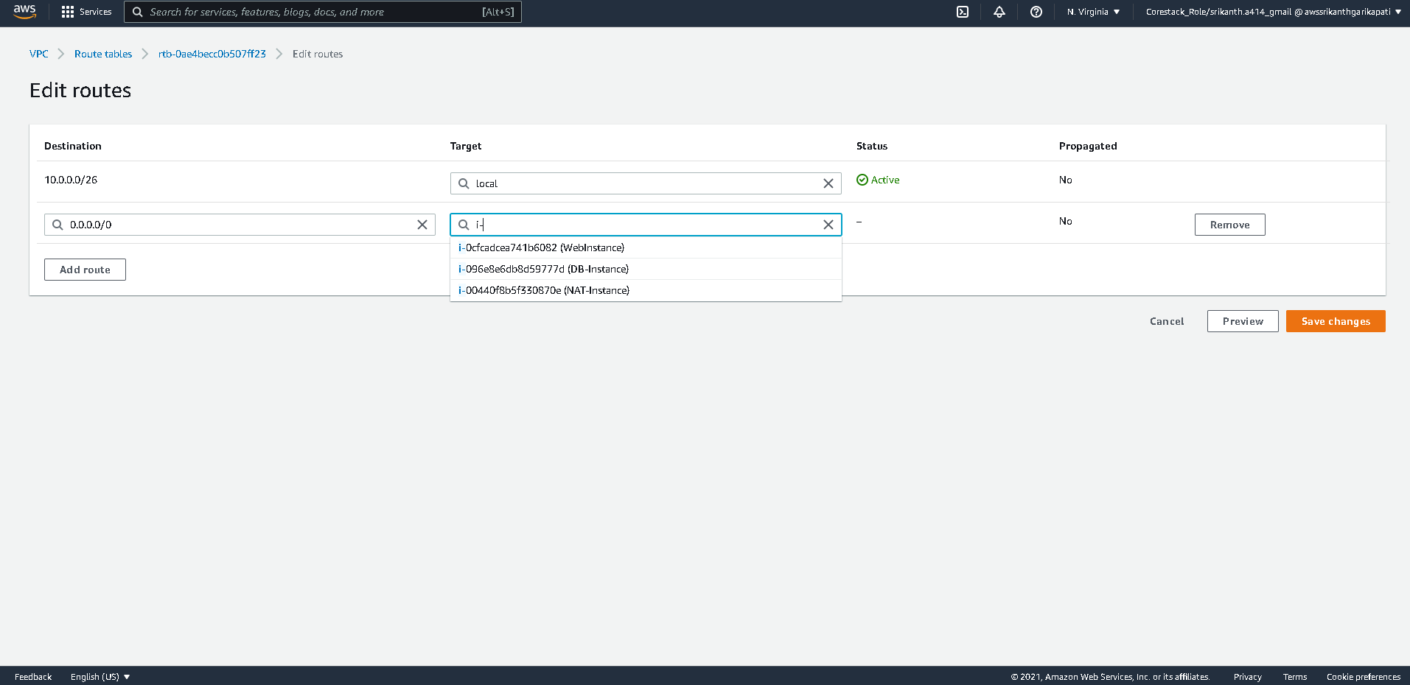

Go to Public Instance and SSH in to instance using Public IP address

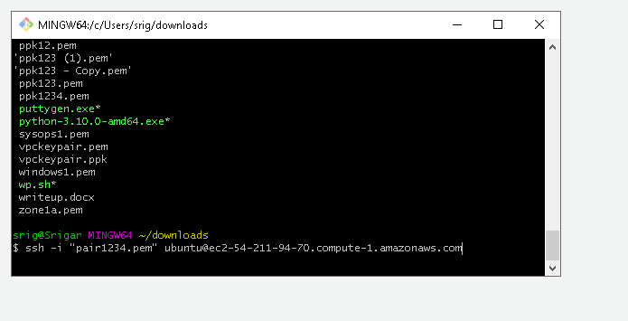

Switch to Super user

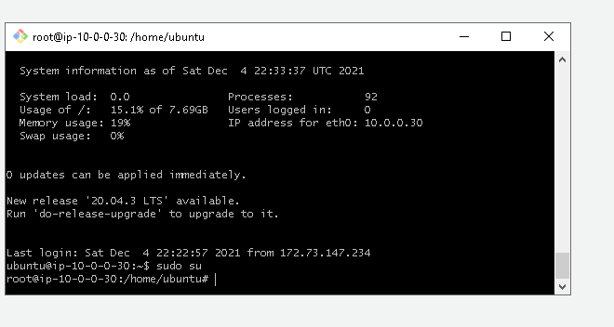

Create SSH key file

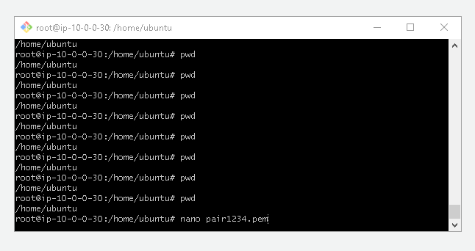

Log in to Private instance via Public Instance

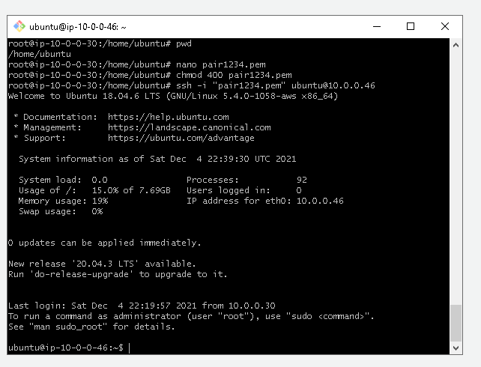

Create SSH key in Private instance as well

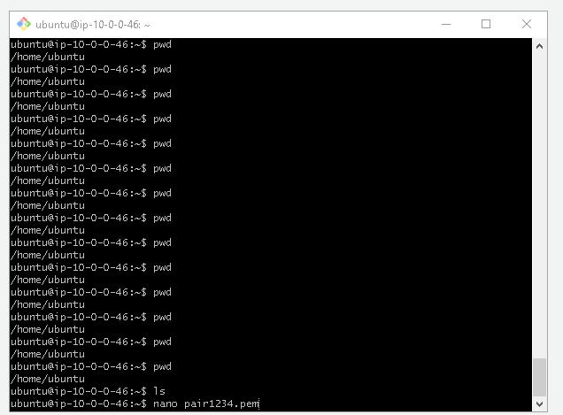

Install DB on Private DB server

Type the following commands step by step

1. Wget <https://storage.googleapis.com/skl-training/aws-codelabs/mattermost/install_mysql.sh>
2. chmod 700 install_mysql.sh
3. sudo ./install_mysql.sh

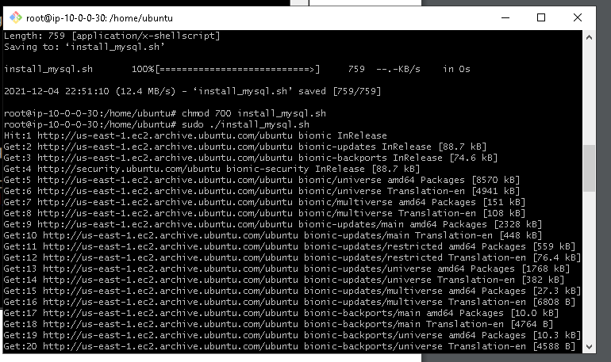

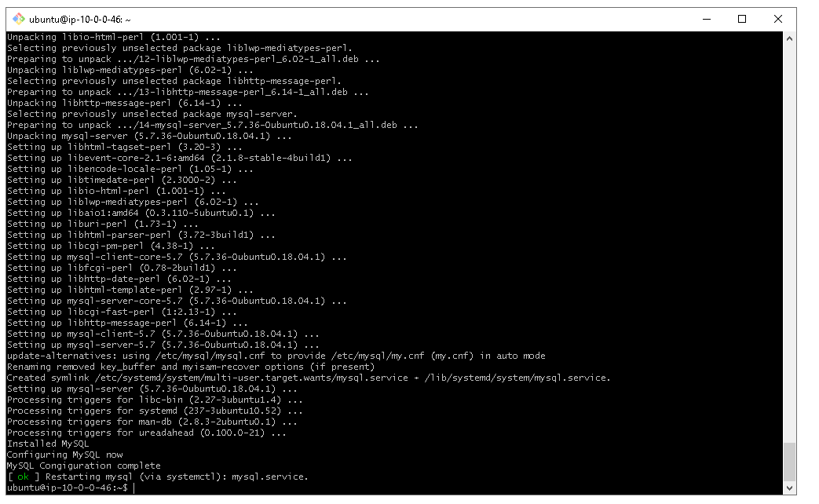

Your DB installation is complete now

Switch Over to your Web-Instance and follow the steps to install Mattermost application

Switch as super user

wget <https://storage.googleapis.com/skl-training/aws-codelabs/mattermost/mattermost_install.sh>

chmod 700 mattermost_install.sh

sudo ./mattermost_install.sh 10.0.0.46

sudo chown -R mattermost:mattermost /opt/mattermost

sudo chmod -R g+w /opt/mattermost

cd /opt/mattermost

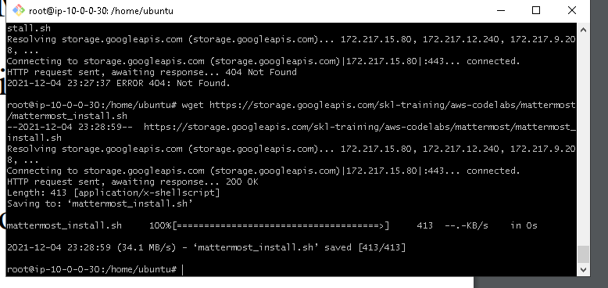

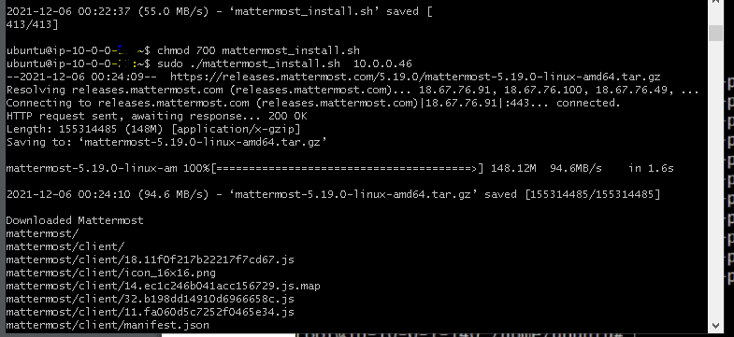

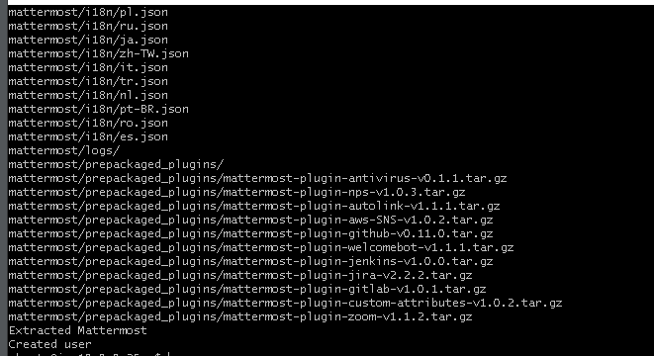

sudo -u mattermost ./bin/mattermost

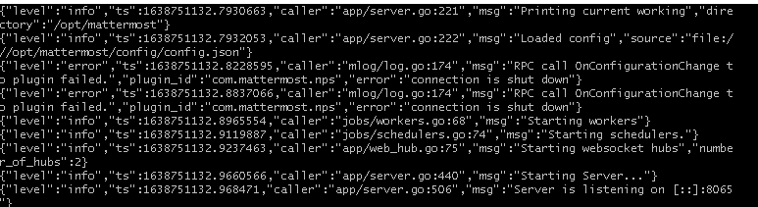

When you receive the message that the server is listening on port: 8065 your setup is complete.

Grab the publicIPv4 of your WebInstance and hit the below url in your browser to view your MatterMost application

<PublicIPV4 of WebInstance>:8065

